**PRACTICAL-1**

**AIM:**

|  |
| --- |
| Install a Bitcoin/Ethereum wallet. Generate and secure your private key. Perform following tasks:   1. a. Create Account/Import Account 2. b. Add ether into account 3. c. Perform transaction to different account |

**OUTPUT:**

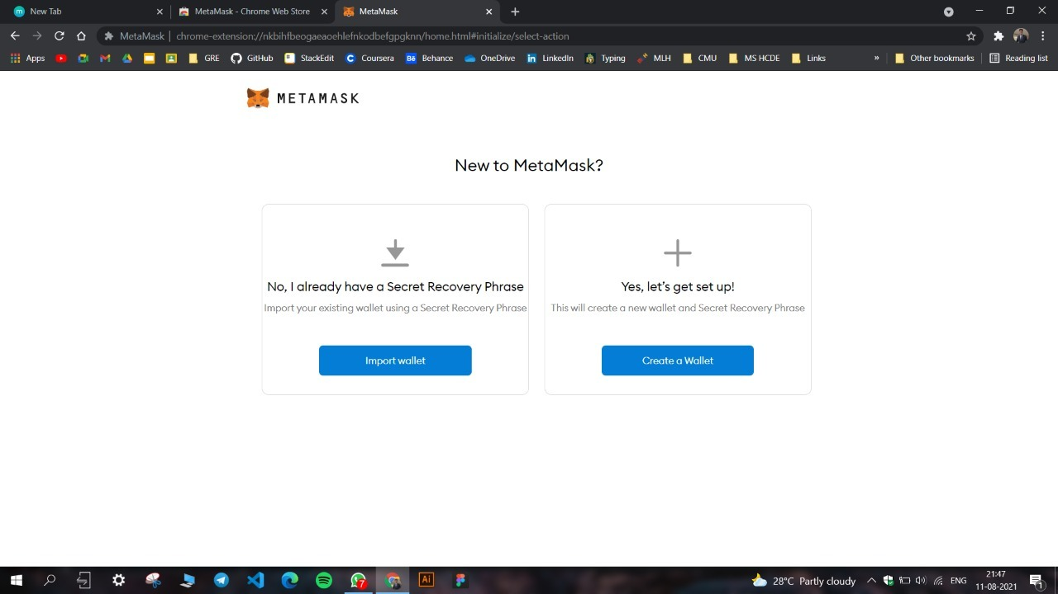

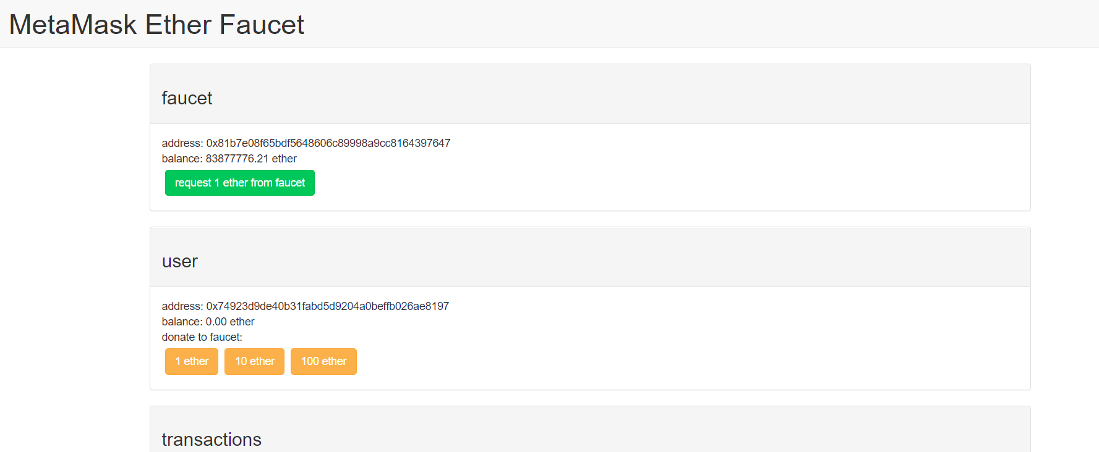

1. Request Test Ethers from Rinkeby Faucet

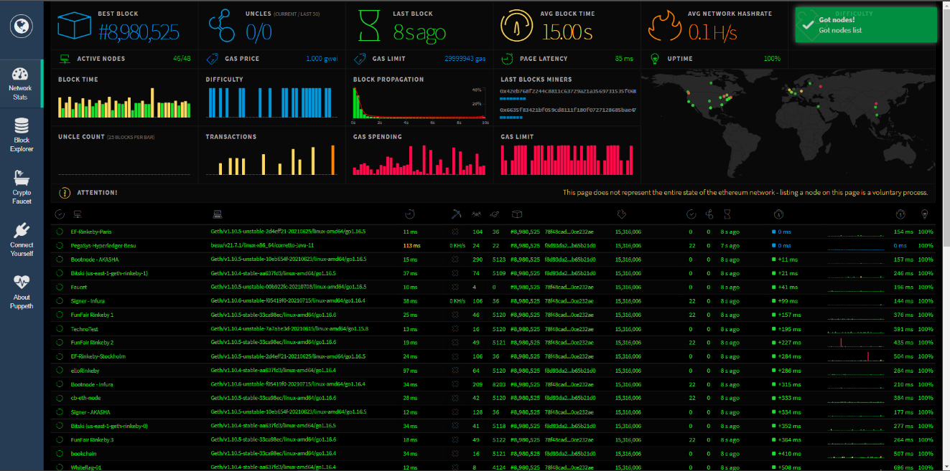

1. Tweet to request ether on an address

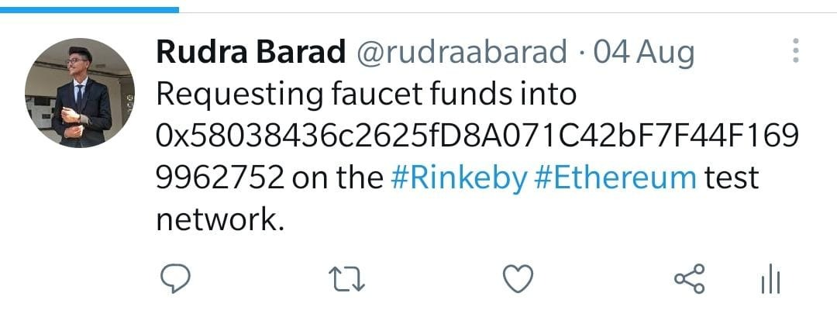

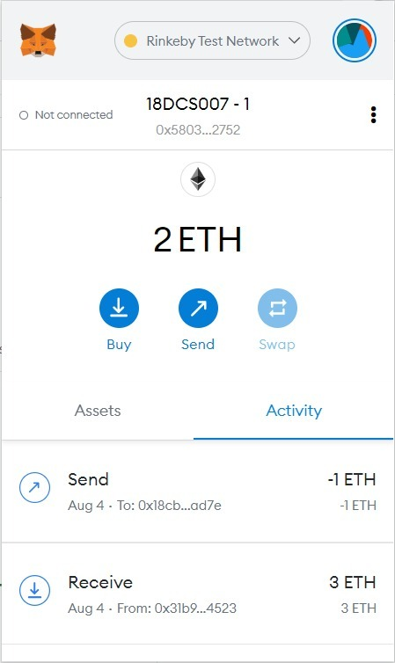 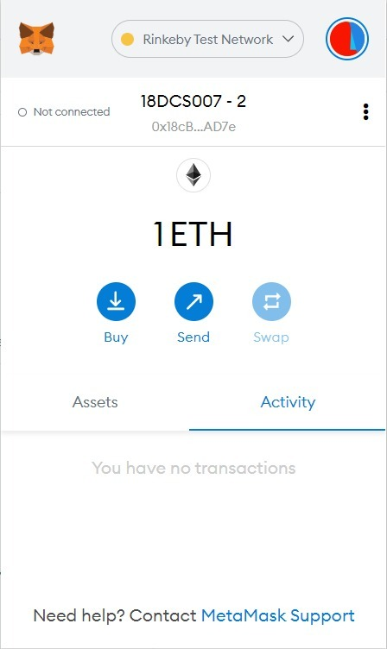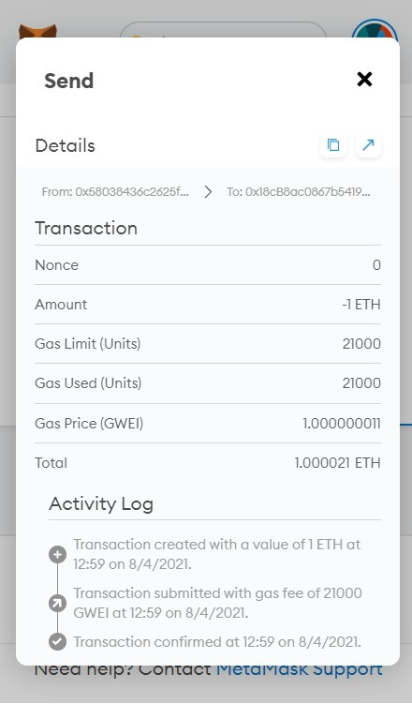

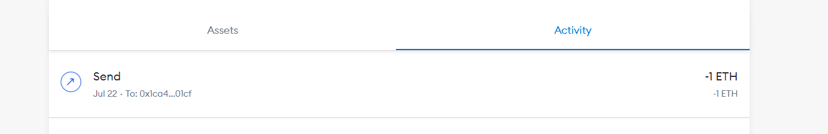

**CONCLUSION:**

In this practical I got to know about Metamask – ETH wallet. Created an account on it and sent ethers to an account.

**PRACTICAL-2**

**AIM:**

|  |  |
| --- | --- |
| |  | | --- | | Write a simple Smart Contract, compile, deploy it using Metamask Ropsten Test Network.  •Setting a Greeting — we should be able to set a greeting.  • Displaying the Greeting — we should be able to retrieve the greeting and display it. |  1. **CODE:** 2. pragma solidity ^0.7.6; 3. contract HelloWorld{ 4. string public hello = "welcome"; 5. function get() public view returns(string memory){ 6. return hello; 7. } 8. function set(string memory msg) public{ 9. hello = msg; 10. } 11. } |

**OUTPUT:**

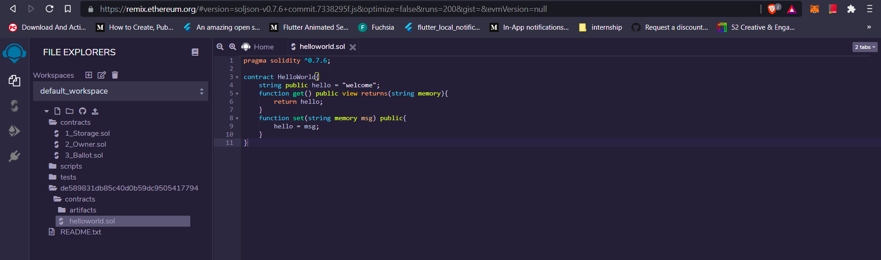 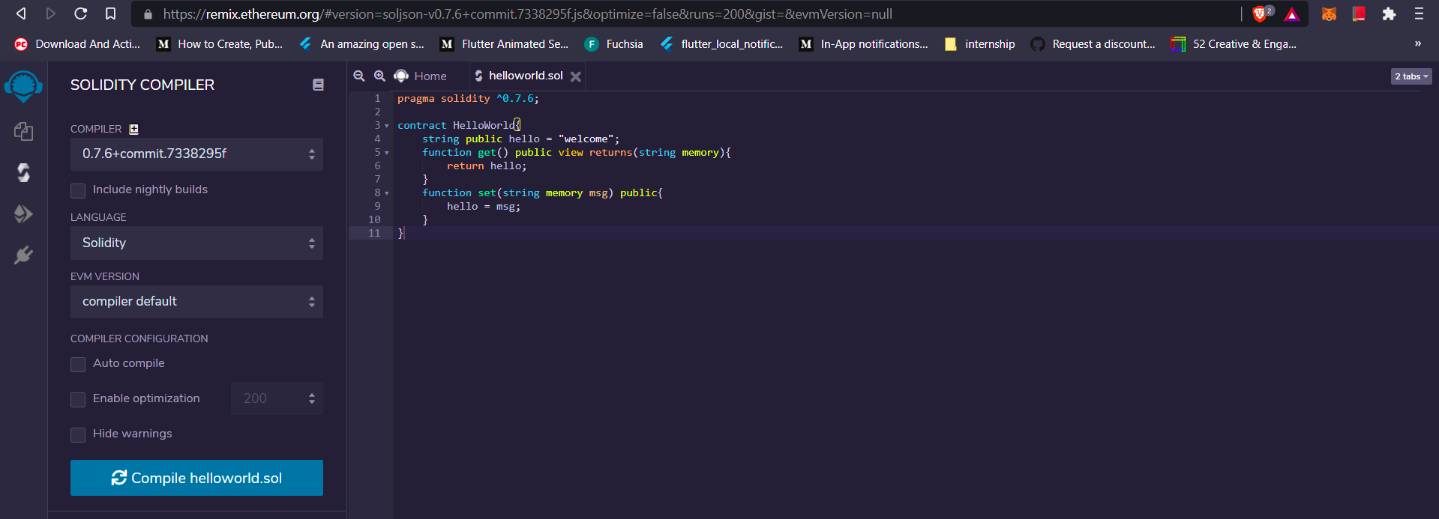 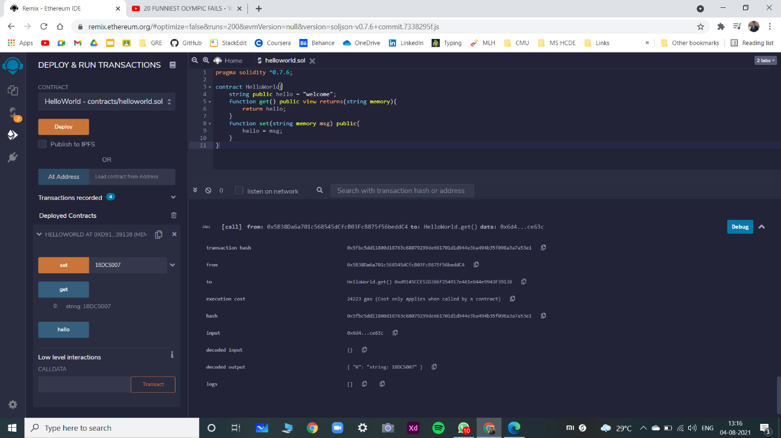

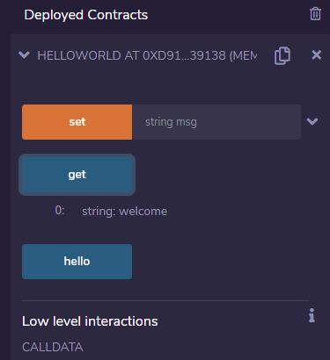 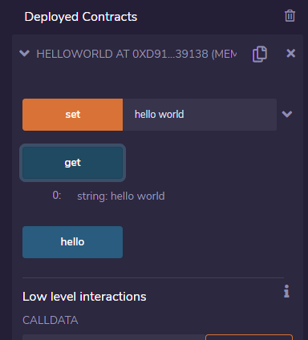

**CONCLUSION:**

In this practical, I created a simple hello world smart contract using solidity language on Remix IDE (Ethereum IDE). Deployed it on Javascript VM.

**PRACTICAL-3**

**AIM:**

|  |  |  |
| --- | --- | --- |
| |  |  | | --- | --- | | |  | | --- | | Write a smart contract of Election with following tasks:   1. a. Cast vote against two candidates 2. b. Vote should be cast only once. 3. c. No voter can vote any third candidate. | |  1. **CODE:** 2. pragma solidity ^0.7.6; 3. contract Election{ 4. struct Candidate{ 5. uint cid; 6. uint votes; 7. string name; 8. } 10. mapping(address => bool) public voters; 11. mapping(uint => Candidate) public candidates; 12. uint public candidateCount; 14. constructor() public{ 15. addCandidate("Tony Bhaiya"); 16. addCandidate("Chintu Coder"); 17. } 19. function addCandidate(string memory _name)public{ 20. candidateCount++; 21. candidates[candidateCount] = Candidate(candidateCount, 0, _name); 22. } 24. function vote(uint _candidateid)public{ 25. require(!voters[msg.sender]); // haven't voted before 26. require(_candidateid > 0 && _candidateid <= candidateCount); //valid Candidate 27. voters[msg.sender]=true; 28. candidates[_candidateid].votes ++; 29. } 30. } |

**OUTPUT:**

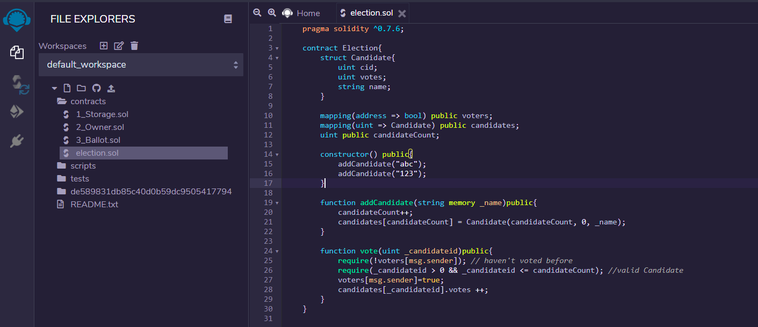

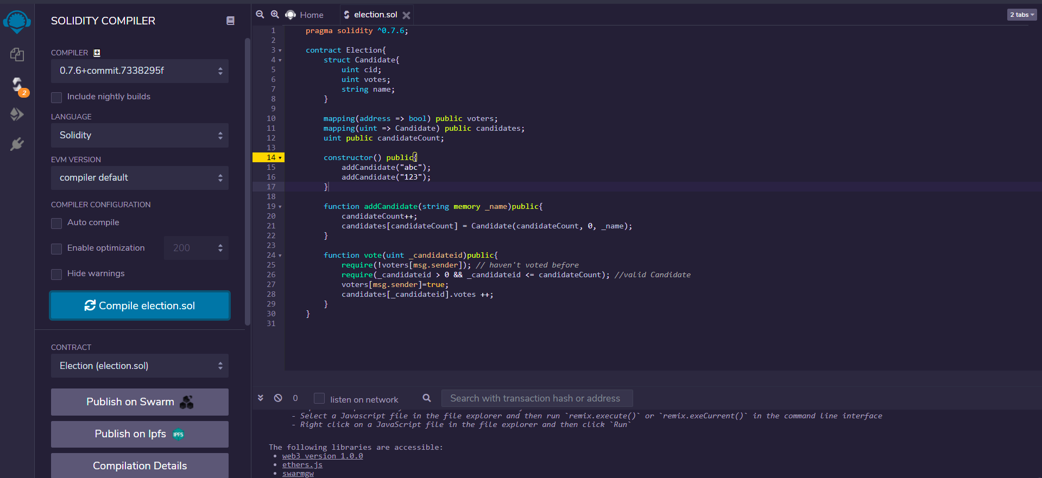

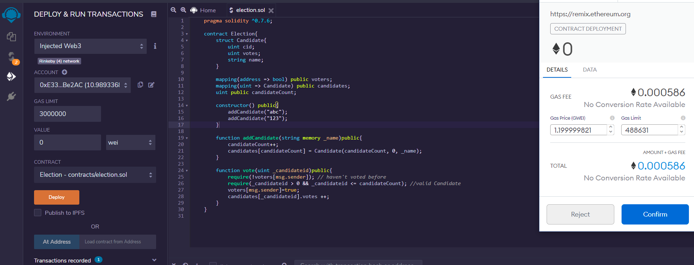 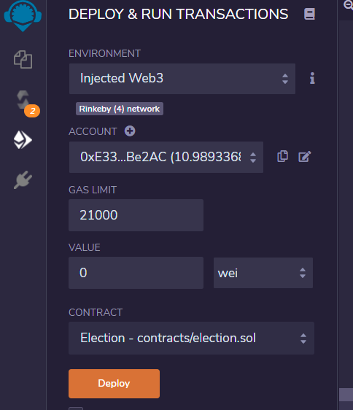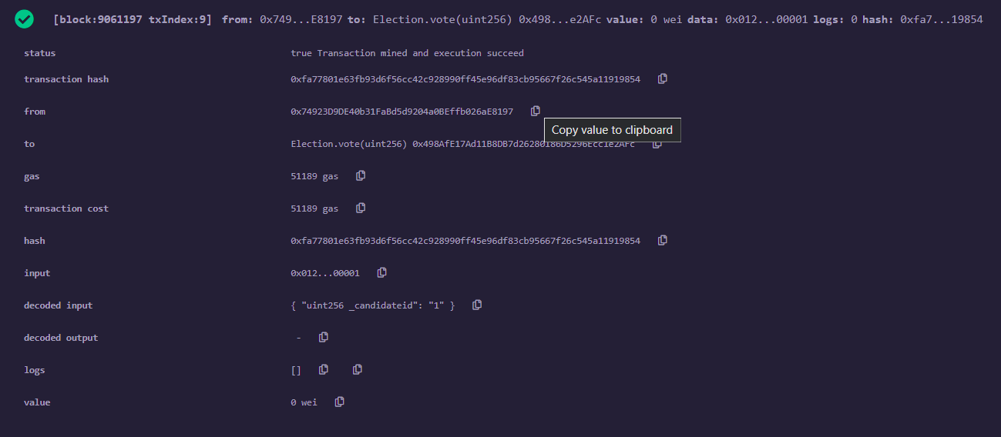

**CONCLUSION:**

In this practical I developed a simple voting system using solidity language on ethereum blockchain. Deployed on web3 by paying some ethers.

**PRACTICAL 4**

**AIM:**

Study and Configure Geth over windows or Ubuntu. Perform following tasks:

1. Build Your Own Private Ethereum Blockchain.
2. Create Genesis Block:
3. Initialize the Genesis block:
4. Create Boot node
5. Start Private Network
6. Launch Ethereum Wallet:
7. Create Address:
8. Start Mining

**STEPS OF IMPLEMENTATION:**

First we will create a main directory. Here we’re naming it “new_geth” but any name will work. Then in cmd, we will navigate to it.

cd new_geth

Then we will make 2 directories inside that folder. We’re naming then n1 and peernode.

mkdir n1

mkdir Peernode

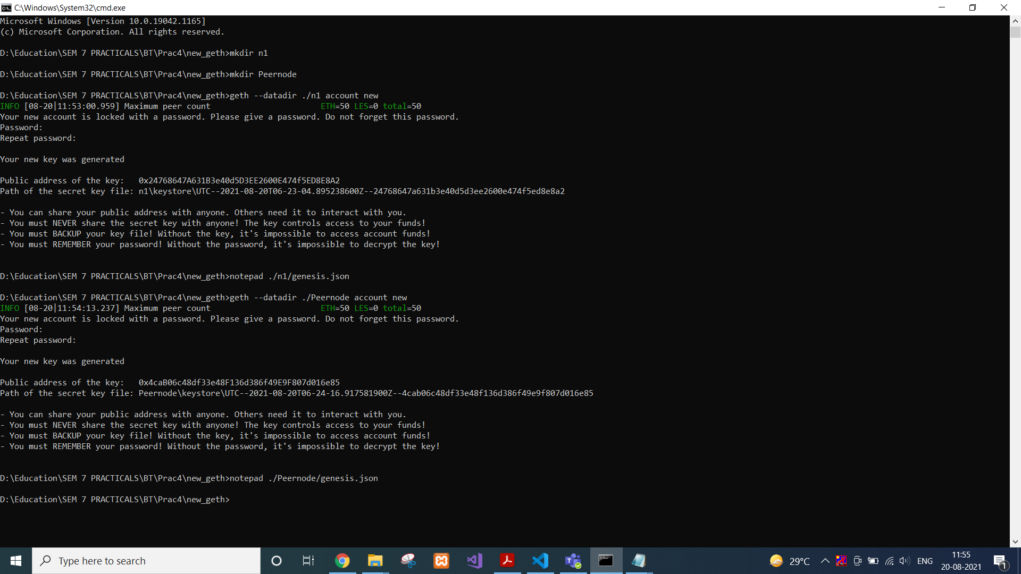

Then we will create new accounts in both the folders with following commands.

geth --datadir ./n1 account new

geth --datadir ./Peernode account new



That would generate public address of both accounts.

We will create genesis.json file in both directories with following code.

{

"config": {

"chainId": 1234,

"homesteadBlock": 0,

"eip150Block": 0,

"eip150Hash": "0x0000000000000000000000000000000000000000000000000000000000000000",

"eip155Block": 0,

"eip158Block": 0,

"byzantiumBlock": 0

},

"difficulty": "400",

"gasLimit": "2000000",

"alloc": {

"<public-address-of-the-key>": {

"balance": "500000000000000000000000"

}

}

}

Then we will initiate both the genesis blocks.

geth --datadir ./n1 init n1/genesis.json

geth --datadir ./Peernode init Peernode/genesis.json

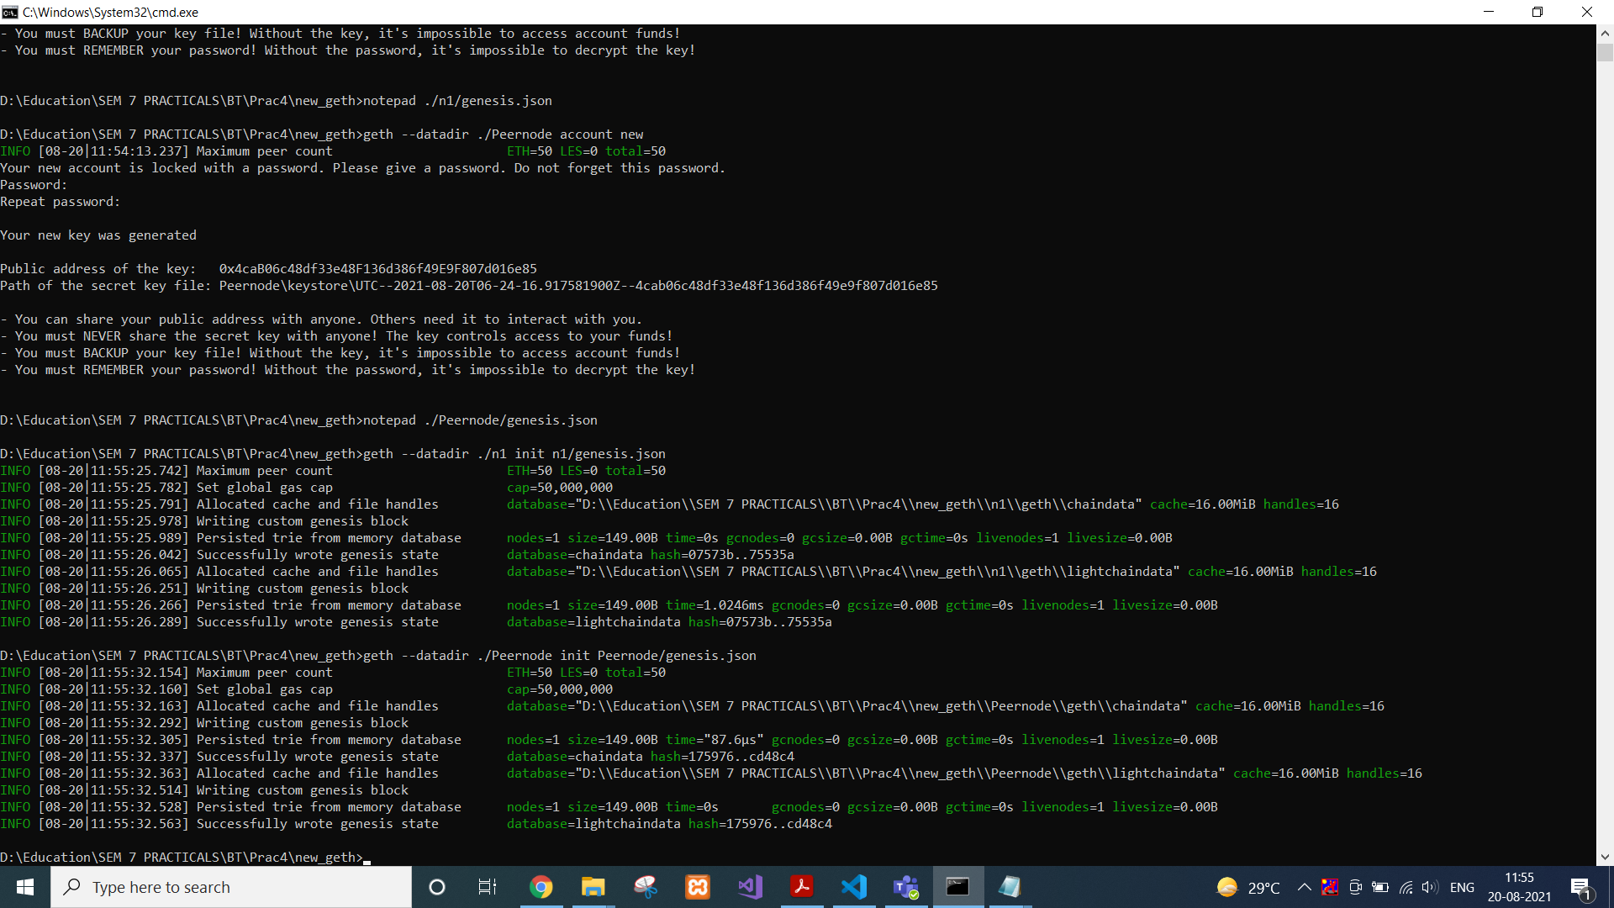

Then we will start interactive javascript environment to interact with our newly created blockchain.

geth --datadir ./n1 --networkid 1234 --ipcdisable --rpc --rpccorsdomain "*" --rpcapi "db,eth,net,web3,personal" --rpcaddr "0.0.0.0" console

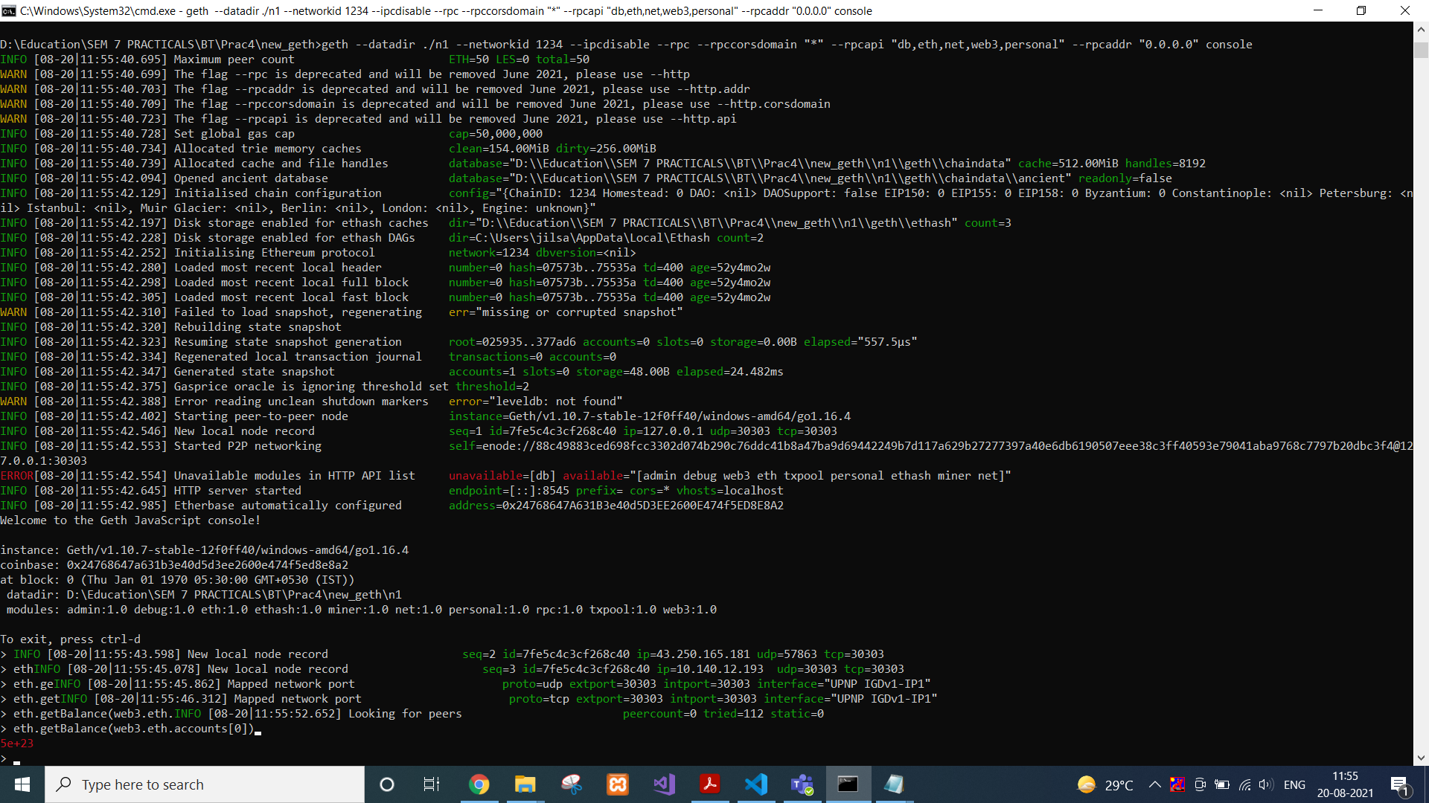

To check balance in our account, we will simply type the following command while the background process is still running.

eth.getBalance(web3.eth.accounts[0])



Admin object exposes methods to interact with the RPC APIs. To get information about enode, we will write following command.

admin.nodeInfo.enode

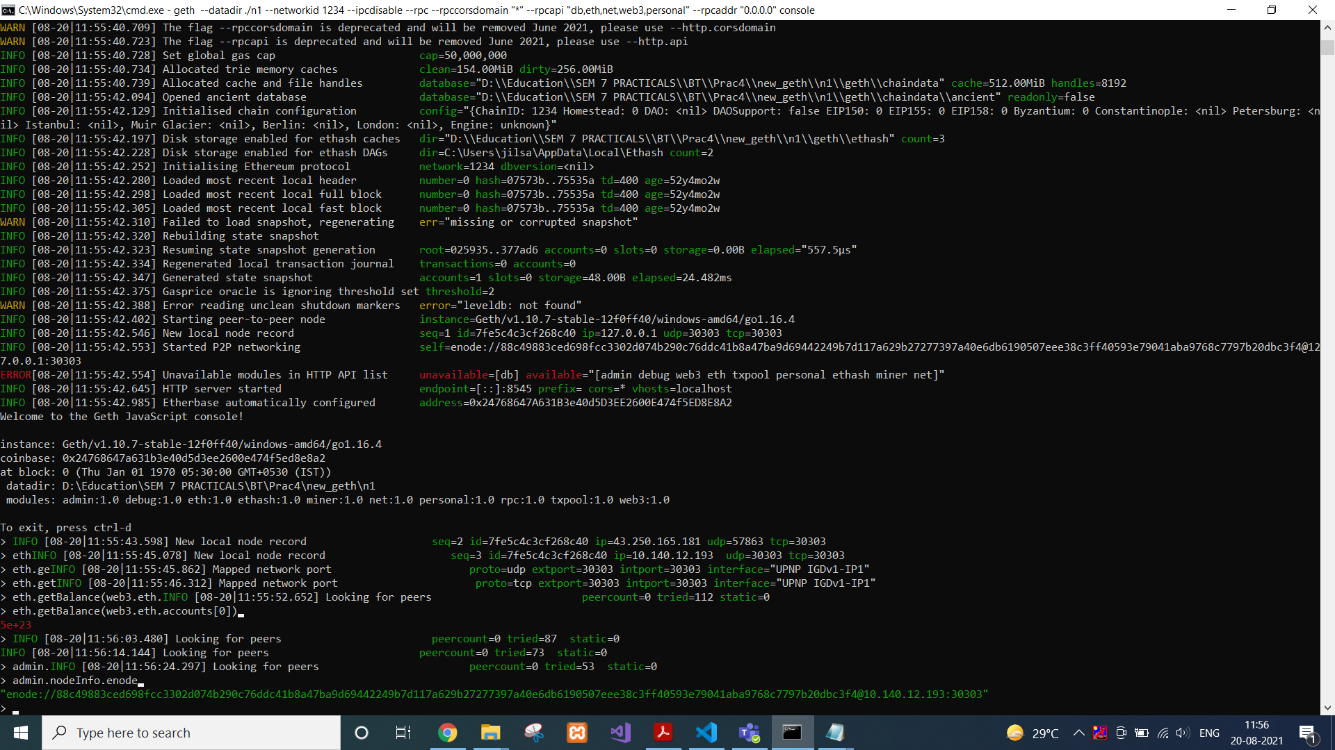

We will copy this enode address and Request adding a new remote node to the list of tracked static nodes.

admin.addPeer("paste the enode address")

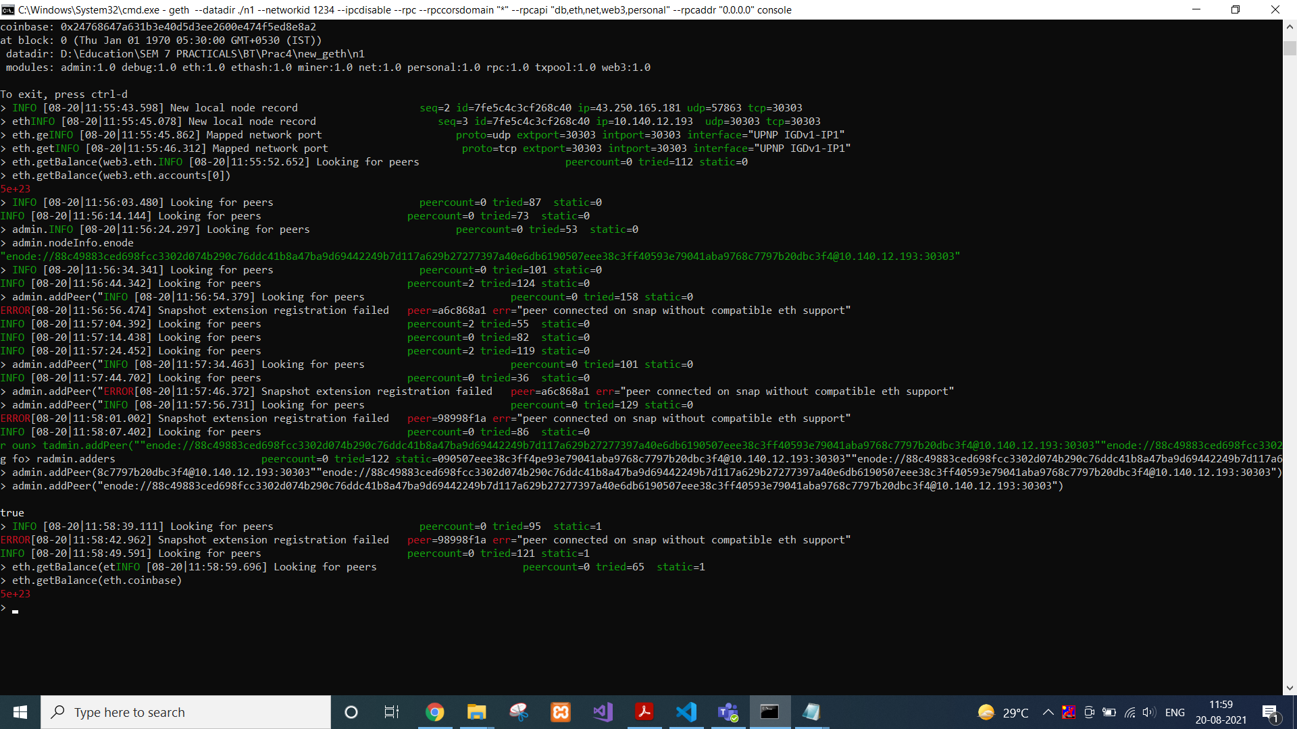

To check your the etherbase account balance, we will use…

eth.getBalance(eth.coinbase)



Now we will set the etherbase, where mining rewards will go.

miner.setEtherbase(web3.eth.accounts[0])

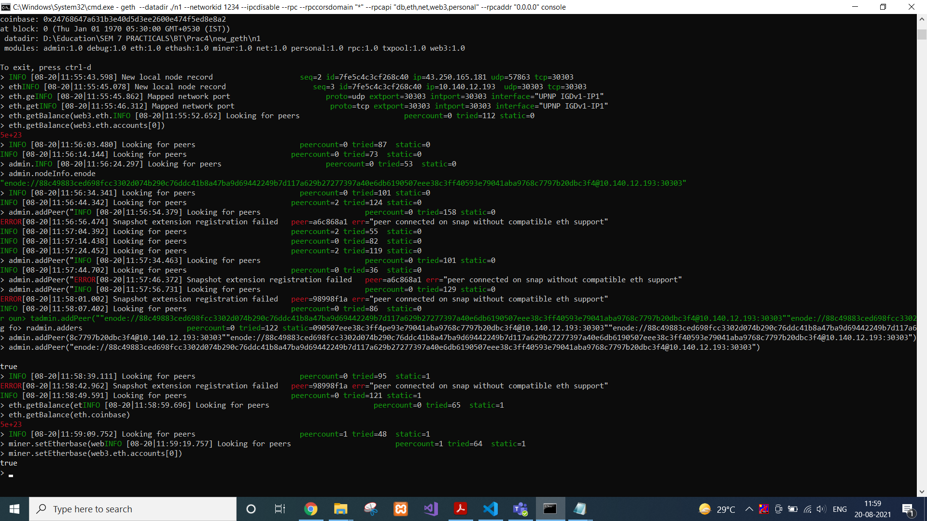

Then finally, we are ready to mine some Ethereum now.

miner.start()

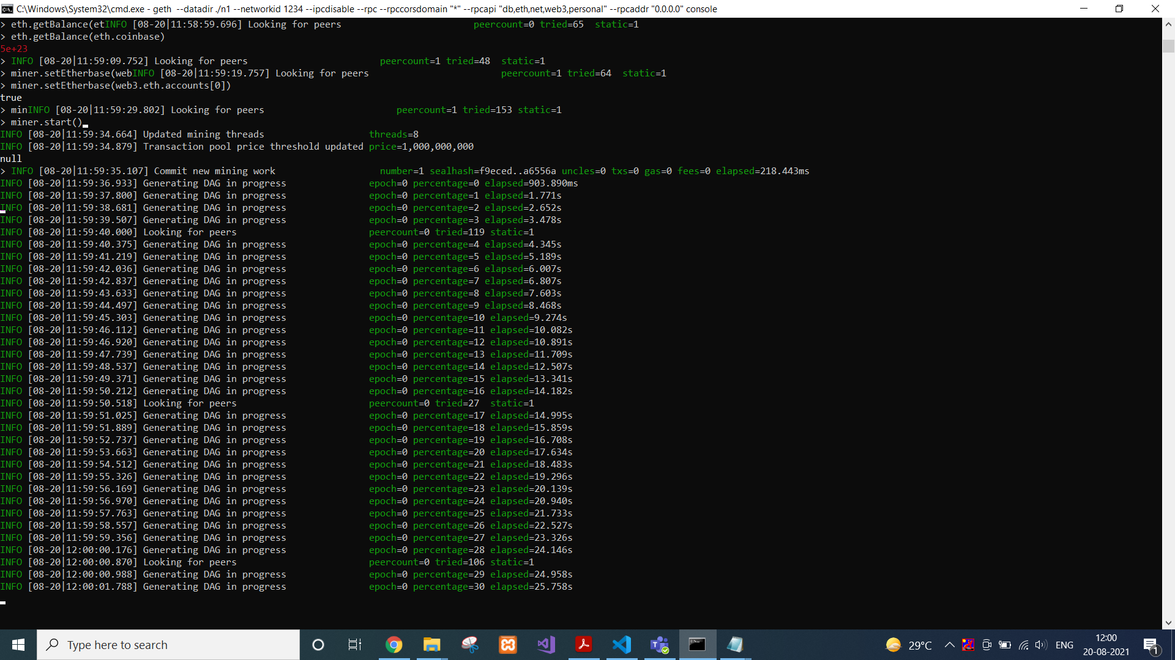

To stop that process, we can use…

miner.stop()

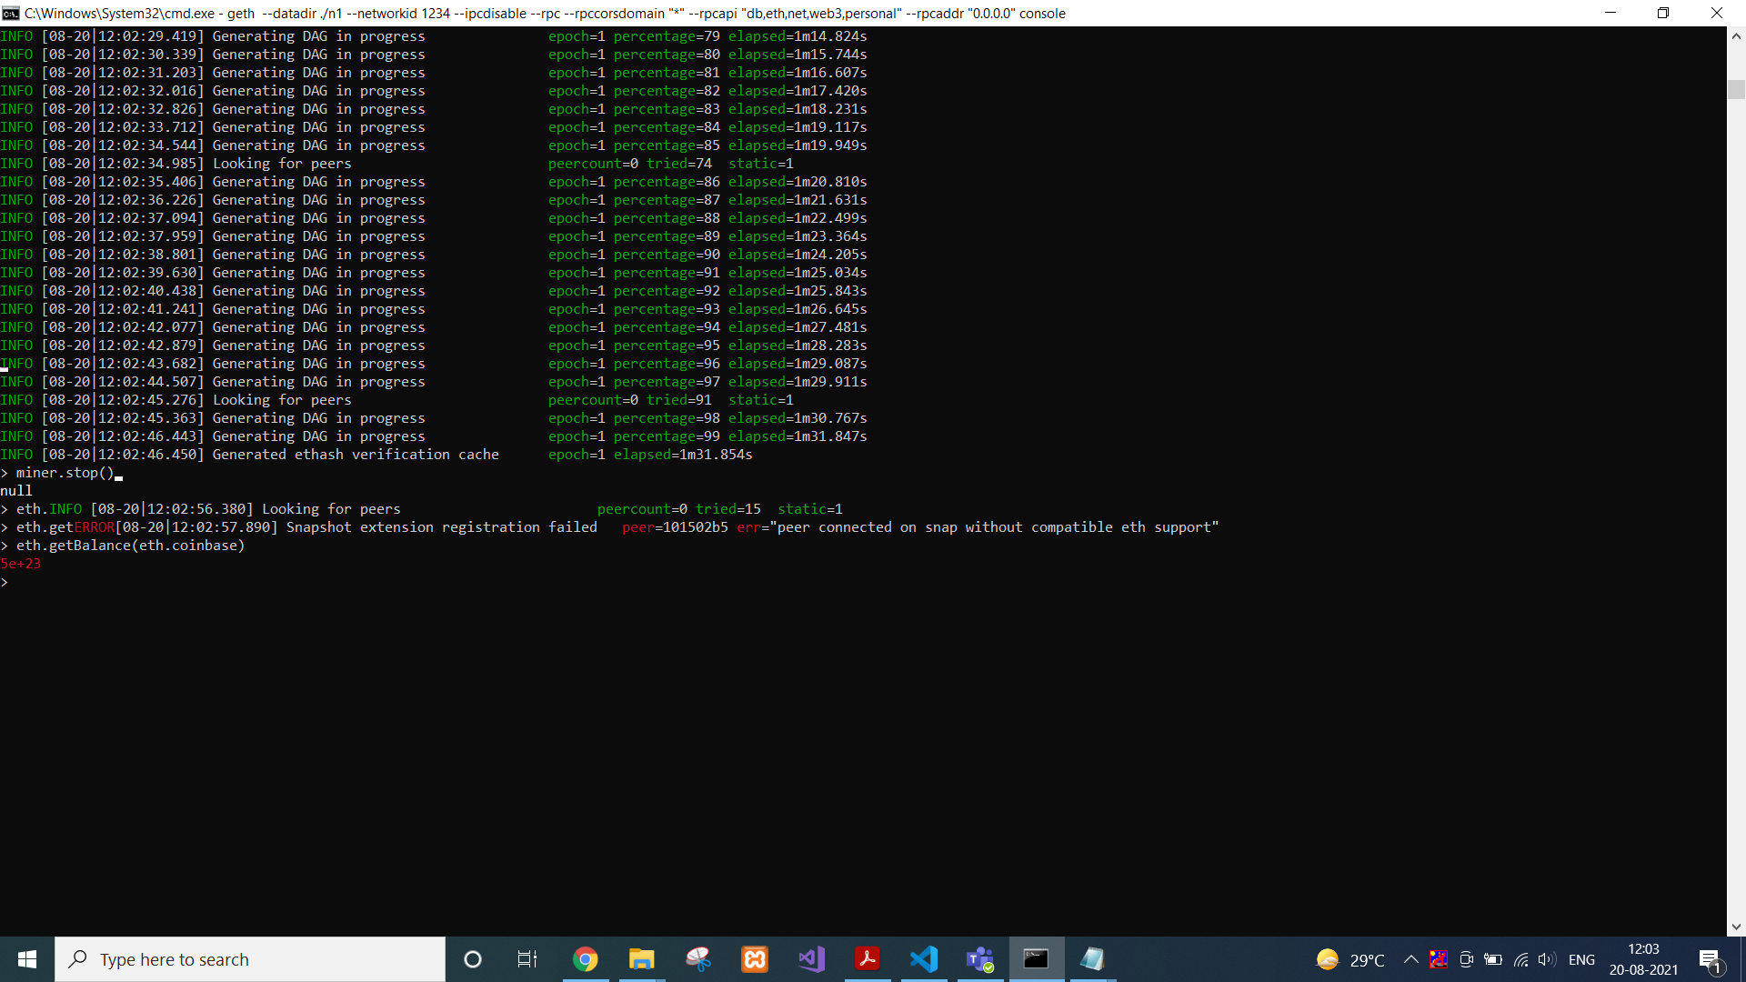

Now we will again check balance with following command. Ideally balance will be less than previous balance i.e. the transaction fees deducted.

eth.getBalance(eth.coinbase)



**CONCLUSION:**

In this practical, we used command prompt and geth to create our private Ethereum blockchain and we mined some Ethereum using it.

**PRACTICAL 5**

**AIM:**

Study and Implement Block structure and perform following tasks using Node js/Python/Java.

1. Create Genesis Block and display.
2. Create three Blocks and link all of them with Genesis block in chronological order.
3. Perform transactions by sending and receiving amount.
4. Mine the transaction (Validation/Verification) and add into block.
5. After adding Block into chain, try to modify or delete the block.
6. View the transaction and Blocks creation over the network.

**PREREQUISITES:**

Node.js installed on your machine.

A code editor, such as Visual Studio Code, Sublime Text, or any other.

**CODE:**

const SHA256 = require("crypto-js/sha256");

class CryptoBlock {

constructor(index, timestamp, data, precedingHash = " ") {

this.index = index;

this.timestamp = timestamp;

this.data = data;

this.precedingHash = precedingHash;

this.hash = this.computeHash();

this.nonce = 0;

}

computeHash() {

return SHA256(

this.index +

this.precedingHash +

this.timestamp +

JSON.stringify(this.data) +

this.nonce

).toString();

}

proofOfWork(difficulty) {

while (

this.hash.substring(0, difficulty) !== Array(difficulty + 1).join("0")

) {

this.nonce++;

this.hash = this.computeHash();

}

}

}

class CryptoBlockchain {

constructor() {

this.blockchain = [this.startGenesisBlock()];

this.difficulty = 4;

}

startGenesisBlock() {

return new CryptoBlock(0, "01/01/2020", "Initial Block in the Chain", "0");

}

obtainLatestBlock() {

return this.blockchain[this.blockchain.length - 1];

}

addNewBlock(newBlock) {

newBlock.precedingHash = this.obtainLatestBlock().hash;

//newBlock.hash = newBlock.computeHash();

newBlock.proofOfWork(this.difficulty);

this.blockchain.push(newBlock);

}

checkChainValidity() {

for (let i = 1; i < this.blockchain.length; i++) {

const currentBlock = this.blockchain[i];

const precedingBlock = this.blockchain[i - 1];

if (currentBlock.hash !== currentBlock.computeHash()) {

return false;

}

if (currentBlock.precedingHash !== precedingBlock.hash) return false;

}

return true;

}

}

let smashingCoin = new CryptoBlockchain();

console.log("smashingCoin mining in progress....");

smashingCoin.addNewBlock(

new CryptoBlock(1, "01/06/2020", {

sender: "Iris Ljesnjanin",

recipient: "Cosima Mielke",

quantity: 50

})

);

smashingCoin.addNewBlock(

new CryptoBlock(2, "01/07/2020", {

sender: "Vitaly Friedman",

recipient: "Ricardo Gimenes",

quantity: 100

})

);

smashingCoin.addNewBlock(

new CryptoBlock(3, "01/08/2020", {

sender: "Cosima Mielke",

recipient: "Vitaly Friedman",

quantity: 80

})

);

console.log(JSON.stringify(smashingCoin, null, 4));

**CODE EXPLANATION:**

const SHA256 = require('crypto-js/sha256');

class CryptoBlock{

constructor(index, timestamp, data, precedingHash=" "){

this.index = index;

this.timestamp = timestamp;

this.data = data;

this.precedingHash = precedingHash;

this.hash = this.computeHash();

}

computeHash(){

return SHA256(this.index + this.precedingHash + this.timestamp + JSON.stringify(this.data)).toString();

}

}

As you can see in the code above, I created the CryptoBlock class and added the constructor() method to it — just like it’s done in any other JavaScript class. Then, to initialize its properties, I assigned the following parameters to the constructor method:

**Index:** It’s a unique number that tracks the position of every block in the entire blockchain.

**Timestamp:** It keeps a record of the time of occurrence of each completed transaction.

**Data:** It provides data about the completed transactions, such as the sender details, recipient’s details, and quantity transacted.

**precedingHash:** It points to the hash of the preceding block in the blockchain, something important in maintaining the blockchain’s integrity.

Furthermore, I used the computeHash method to calculate the hash of the block based on its properties, as given in the data above.

As you can see, I imported the crypto-js JavaScript library and used its crypto-js/sha256 module to calculate the hash of each block. Since the module returns a number object, I used the toString() method to convert it into a string.

Let’s create a CryptoBlockchain class that will be responsible for handling the operations of the entire chain.

The CryptoBlockchain class will maintain the operations of the blockchain using helper methods that accomplish different tasks, such as creating new blocks and adding them to the chain.

class CryptoBlockchain{

constructor(){

this.blockchain = [this.startGenesisBlock()];

}

startGenesisBlock(){

return new CryptoBlock(0, "01/01/2020", "Initial Block in the Chain", "0");

}

obtainLatestBlock(){

return this.blockchain[this.blockchain.length - 1];

}

addNewBlock(newBlock){

newBlock.precedingHash = this.obtainLatestBlock().hash;

newBlock.hash = newBlock.computeHash();

this.blockchain.push(newBlock);

}

}

In a blockchain, the genesis block refers to the first-ever block created on the network. Whenever a block is integrated with the rest of the chain, it should reference the preceding block.

Conversely, in the case of this initial block, it does not have any preceding block to point to. Therefore, a genesis block is usually hardcoded into the blockchain. This way, subsequent blocks can be created on it. It usually has an index of 0.

I used the startGenesisBlock() method to create the genesis block. Notice that I created it using the afore-created CryptoBlock class and passed the index, timestamp, data, and precedingHash parameters.

Getting the latest block in the blockchain assists in ensuring the hash of the current block points to the hash of the previous block — thus maintaining the chain’s integrity.

I used the obtainLatestBlock() method to retrieve it.

I used the addNewBlock() method to add a new block to the chain. To accomplish this, I set the previous hash of the new block to be equal to the hash of the last block in the chain — thus ensuring the chain is tamper-proof.

Since the properties of the new block get changed with every new calculation, it’s important to calculate its cryptographic hash again. After updating its hash, the new block is pushed into the blockchain array.

let smashingCoin = new CryptoBlockchain();

smashingCoin.addNewBlock(new CryptoBlock(1, "01/06/2020", {sender: "Iris Ljesnjanin", recipient: "Cosima Mielke", quantity: 50}));

smashingCoin.addNewBlock(new CryptoBlock(2, "01/07/2020", {sender: "Vitaly Friedman", recipient: "Ricardo Gimenes", quantity: 100}) );

console.log(JSON.stringify(smashingCoin, null, 4));

As you can see in the code above, I created a new instance of the CryptoBlockchain class and named it as smashingCoin. Then, I added two blocks into the blockchain using some arbitrary values. In the data parameter, I used an object and added sender details, recipient’s details, and quantity transacted.

To verify the integrity of the blockchain, I’ll add a checkChainValidity() method to the CryptoBlockchain class.

Hashes are critical for ensuring the validity and security of a blockchain because any change in the contents of a block will result in the production of an entirely new hash, and invalidating the blockchain.

As such, the checkChainValidity() method will make use of if statements to verify whether the hash of every block has been tampered with. Starting from the first created block, it’ll loop over the entire blockchain and check for its validity. Note that since the genesis block was hardcoded, it’ll not be checked.

Also, the method will verify whether the hashes of each two consecutive blocks are pointing to one another. If the integrity of the blockchain has not been compromised, it returns true; otherwise, in case of any anomalies, it returns false.

checkChainValidity(){

for(let i = 1; i < this.blockchain.length; i++){

const currentBlock = this.blockchain[i];

const precedingBlock= this.blockchain[i-1];

if(currentBlock.hash !== currentBlock.computeHash()){

return false;

}

if(currentBlock.precedingHash !== precedingBlock.hash)

return false;

}

return true;

}

In the case of smashingCoin, I’ll employ a simple algorithm that deters people from generating new blocks easily or spamming the blockchain.

So, in the CryptoBlock class, I’ll add another method called proofOfWork().Essentially, this simple algorithm identifies a number, passed as a difficulty property, such that the hash of every block contains leading zeros that correspond to this difficulty level.

Ensuring the hash of every block begins with the number of zeros as set in the difficulty level requires a lot of computing power. The higher the difficulty level, the more time it takes to mine new blocks.

Furthermore, I’ll add a random nonce value to every hashed block such that, when rehashing takes place, the difficulty level restrictions can still be met.

proofOfWork(difficulty){

while(this.hash.substring(0, difficulty) !==Array(difficulty + 1).join("0")){

this.nonce++;

this.hash = this.computeHash();

}

}

computeHash(){

return SHA256(this.index + this.precedingHash + this.timestamp + JSON.stringify(this.data)+this.nonce).toString();

}

Additionally, to implement the proof of work mechanism in the generation of new blocks, I’ll include it in the addNewBlock() method:

addNewBlock(newBlock){

newBlock.precedingHash = this.obtainLatestBlock().hash;

//newBlock.hash = newBlock.computeHash();

newBlock.proofOfWork(this.difficulty);

this.blockchain.push(newBlock);

}

**OUTPUT:**

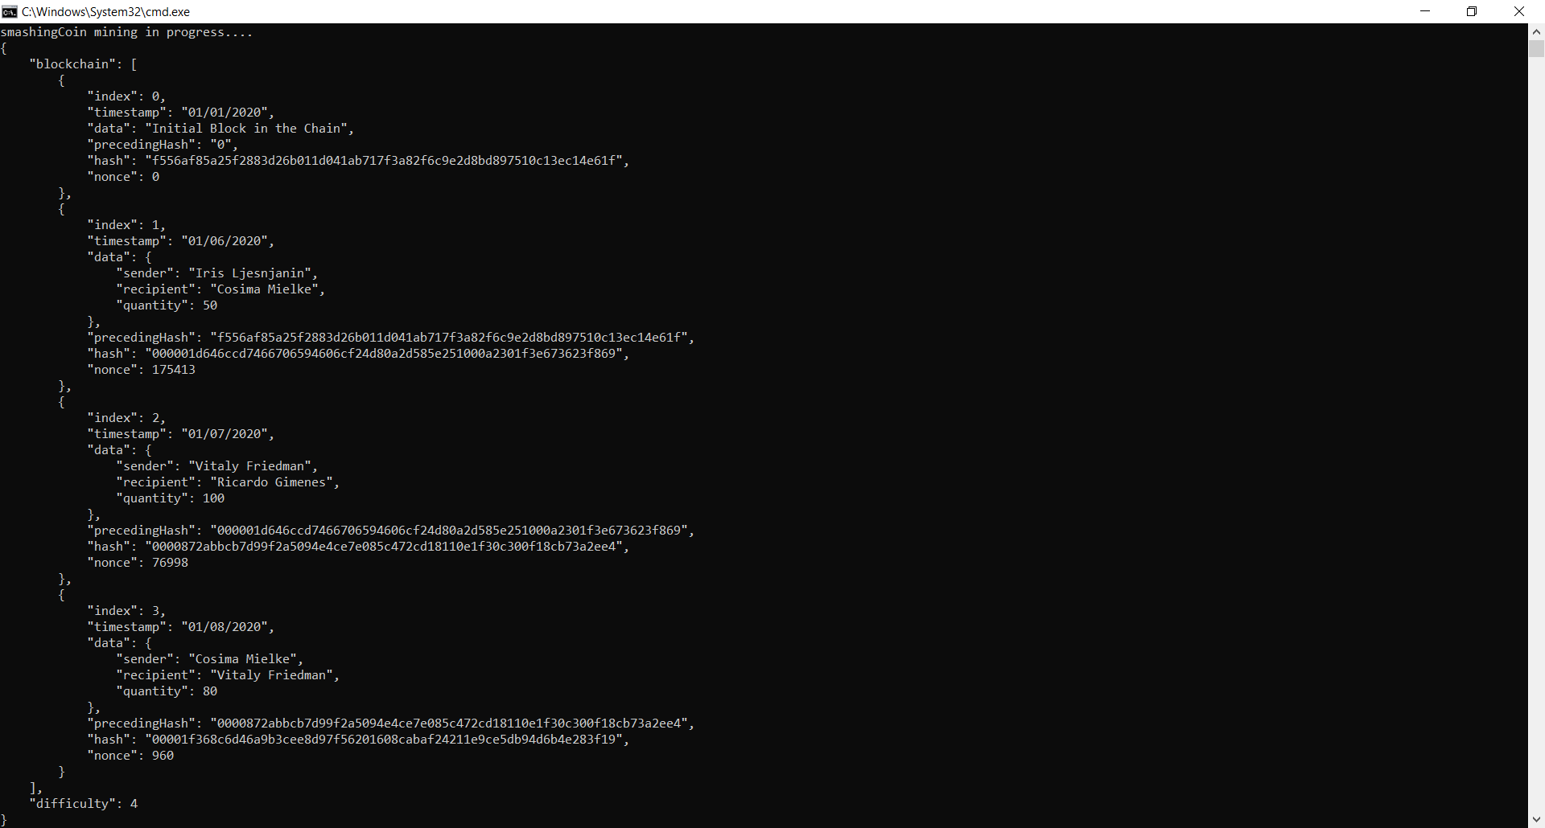

**CONCLUSION:**

In this practical, we thoroughly understood the concept of blockchain and implemented our own cryptocurrency using Node JS with proof of work consensus mechanism.

**PRACTICAL-6**

**AIM :** Install the development environment to set up the Hyperledger Composer Playground.

**Tool Introduction:**

1. Hyperledger Composer Playground–
   * Hyperledger Composer is an extensive, open development toolset and framework to make developing blockchain applications easier. Our primary goal is to accelerate time to value, and make it easier to integrate your blockchain applications with the existing business systems. You can use Composer to rapidly develop use cases and deploy a blockchain solution in weeks rather than months. Composer allows you to model your business network and integrate existing systems and data with your blockchain applications.
   * Hyperledger Composer supports the existing Hyperledger Fabric blockchain infrastructure and runtime, which supports pluggable blockchain consensus protocols to ensure that transactions are validated according to policy by the designated business network participants.
   * Everyday applications can consume the data from business networks, providing end users with simple and controlled access points.
   * You can use Hyperledger Composer to quickly model your current business network, containing your existing assets and the transactions related to them; assets are tangible or intangible goods, services, or property. As part of your business network model, you define the transactions which can interact with assets. Business networks also include the participants who interact with them, each of which can be associated with a unique identity, across multiple business networks.

**Steps to install Hyperledger Composer Playground :**

1. To install Hyperledger Composer Playground, first we have to install prerequisites for it. To install prerequisites run below command into ubuntu cmd/Terminal.
   1. curl -O https://hyperledger.github.io/composer/latest/prereqs-ubuntu.sh
   2. chmod u+x prereqs-ubuntu.sh
   3. ./prereqs-ubuntu.sh

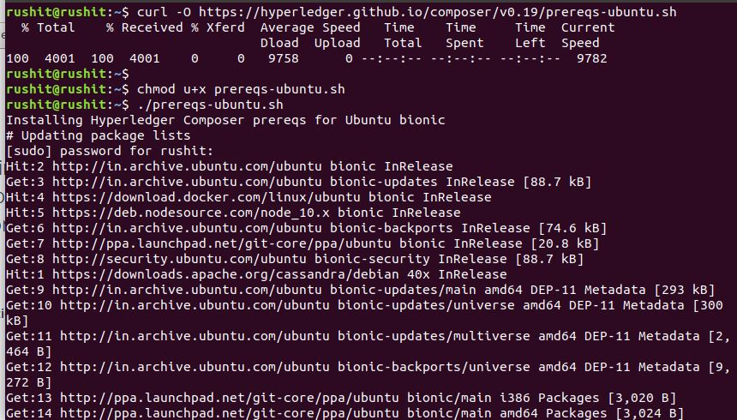

1. There are a few useful **CLI tools** for Composer developers. The most important one is **composer-cli**, which contains all the essential operations, so we'll install that first. Next, we'll also pick up **generator-hyperledger-composer**, **composer-rest-server** and **Yeoman**. Those last 3 are not core parts of the development environment, but they'll be useful if you're following the tutorials or developing applications that interact with your Business Network, so we'll get them installed now.

**Note: you should not use su or sudo for the following npm commands.**

1. Essential CLI tools:
   1. npm install -g composer-cli@0.19

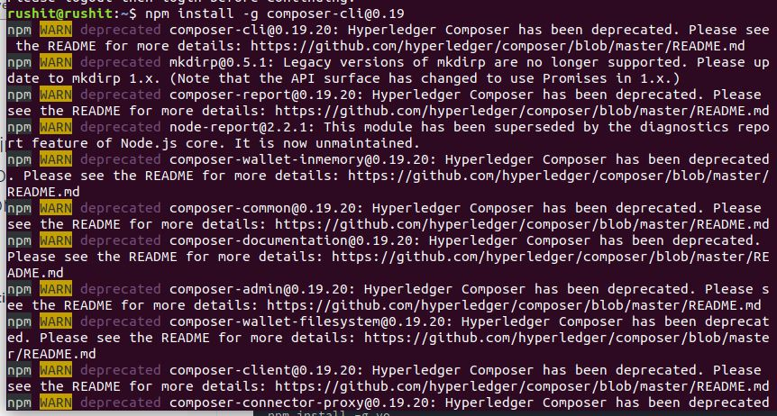

1. Utility for running a REST Server on your machine to expose your business networks as RESTful APIs:
   1. npm install -g composer-rest-server@0.19

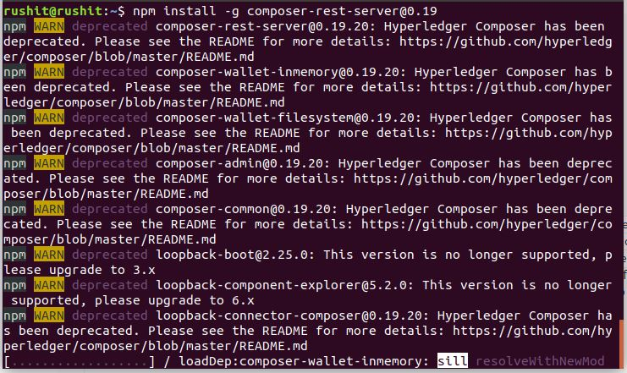

1. Useful utility for generating application assets:
   1. npm install -g generator-hyperledger-composer@0.19

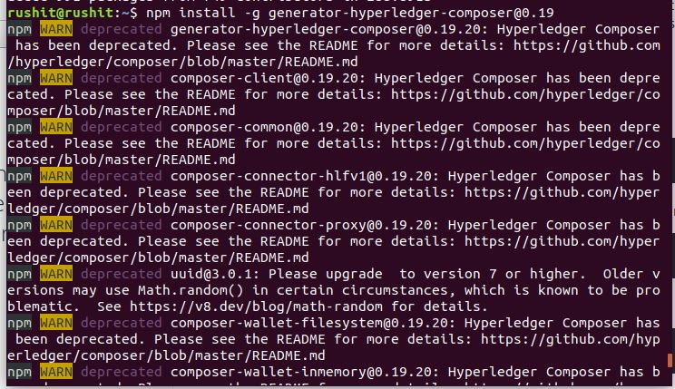

1. Yeoman is a tool for generating applications, which utilises generator-hyperledger-composer:
   1. npm install -g yo

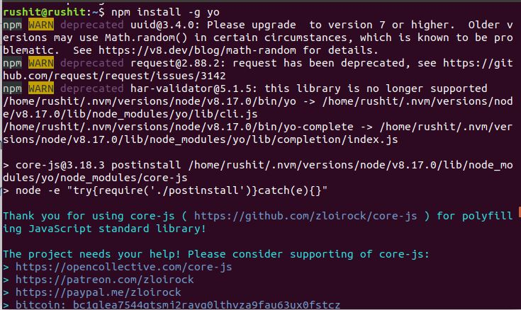

1. Now we will install playground. If you've already tried Composer online, you'll have seen the browser app "Playground". You can run this locally on your development machine too, giving you a UI for viewing and demonstrating your business networks.
2. Browser app for simple editing and testing Business Networks:
   1. npm install -g composer-playground@0.19

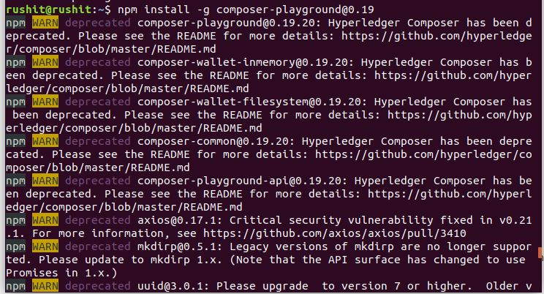

1. After installing playground, lets install hyperledger fabric.
2. In a directory of your choice (we will assume ~/fabric-dev-servers), get the .tar.gz file that contains the tools to install Hyperledger Fabric:
   1. mkdir ~/fabric-dev-servers && cd ~/fabric-dev-servers
   2. curl -O https://raw.githubusercontent.com/hyperledger/composer-tools/master/packages/fabric-dev-servers/fabric-dev-servers.tar.gz
   3. tar -xvf fabric-dev-servers.tar.gz

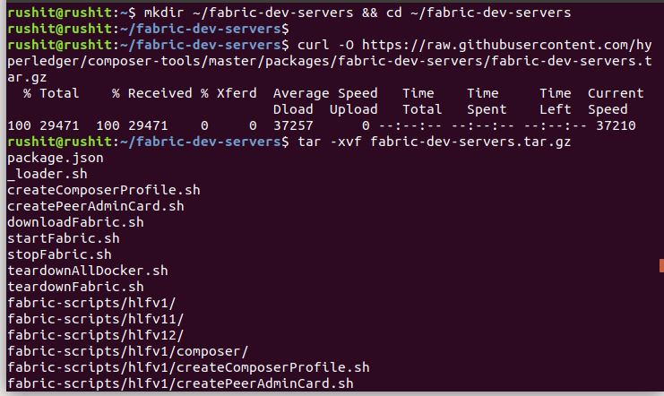

1. Use the scripts you just downloaded and extracted to download a local Hyperledger Fabric v1.2 runtime:
   1. cd ~/fabric-dev-servers
   2. export FABRIC_VERSION=hlfv12
   3. ./downloadFabric.sh

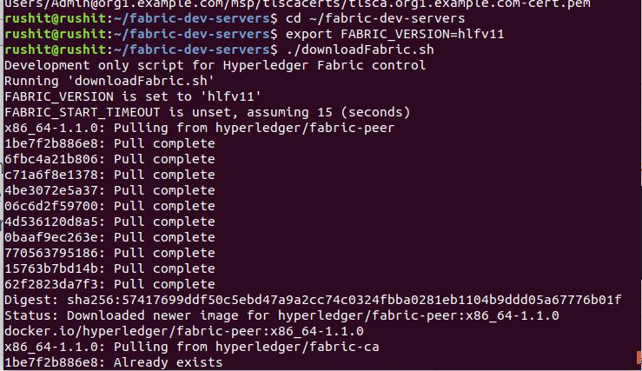

1. For the first time you start up a new runtime, you'll need to run the start script, then generate a PeerAdmin card:
   1. cd ~/fabric-dev-servers
   2. export FABRIC_VERSION=hlfv12
   3. ./startFabric.sh
   4. ./createPeerAdminCard.sh

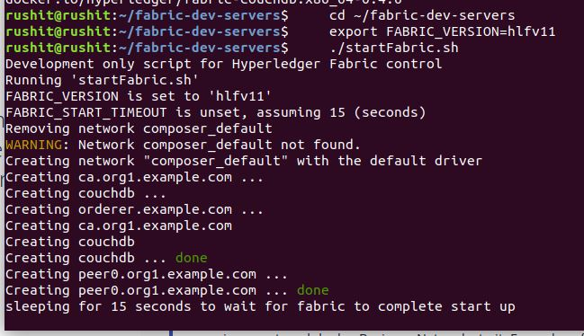

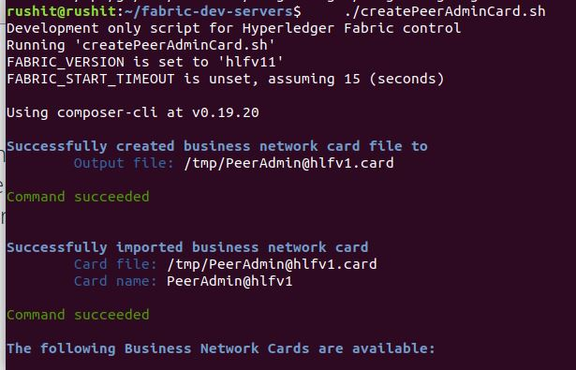

1. To start the web app, run:
   1. composer-playground

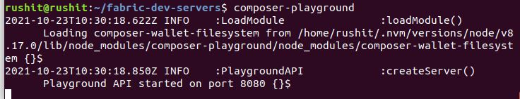

1. After running above step you will get an browser window that shown in the below images.

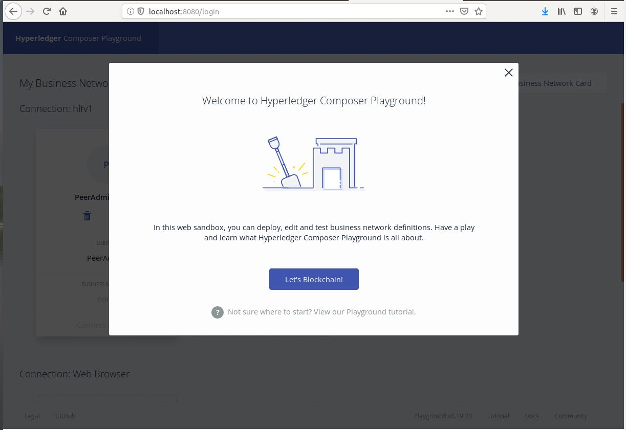

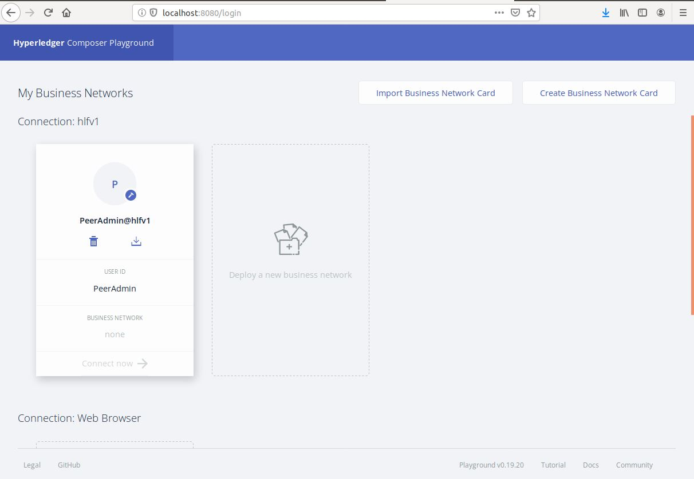

**CONCLUSION:**

In this practical, we learned about Hyperledger Composer Playground.

**PRACTICAL 7**

**AIM:**

Create simple application using Hyperledger playground.

**PRACTICAL:**

**Step One: Open the Hyperledger Composer Playground**

Open Composer Playground. You should see the My Business Network screen. The My Business Network page shows you a summary of the business networks you can connect to, and the identities you can use to connect to them.

**Step Two: Creating a new business network**

We want to create a new business network from scratch. A business network has a couple of defining properties; a name, and an optional description. You can also choose to base a new business network on an existing template, or import your own template.

1. Click Deploy a new business network under the Web Browser heading to get started.
2. The new business network needs a name, let's call it tutorial-network.
3. Optionally, you can enter a description for your business network.
4. Next we must select a business network to base ours on, because we want to build the network from scratch, click empty-business-network.
5. Now that our network is defined, click Deploy.

**Step Three: Connecting to the business network**

Now that we've created and deployed the business network, you should see a new business network card called admin for our business network tutorial-network in your wallet. The wallet can contain business network cards to connect to multiple deployed business networks.

When connecting to an external blockchain, business network cards represent everything necessary to connect to a business network. They include connection details, authentication material, and metadata.

To connect to our business network click Connect now under our business network card.

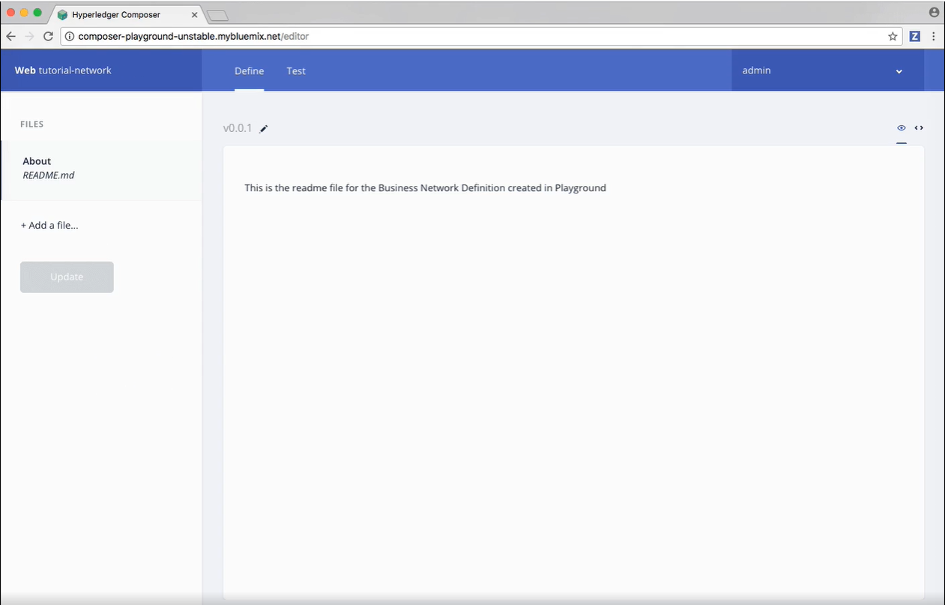

**Step Four: Adding a model file**

As you can see, we're in the Define tab right now, this tab is where you create and edit the files that make up a business network definition, before deploying them and testing them using the Test tab.

As we selected an empty business network template, we need to define our business network files. The first step is to add a model file. Model files define the assets, participants, transactions, and events in our business network.

1. Click the Add a file button.
2. Click the Model file and click Add.
3. Delete the lines of code in the model file and replace it with this:

/**

* My commodity trading network

*/

namespace org.acme.mynetwork

asset Commodity identified by tradingSymbol {

o String tradingSymbol

o String description

o String mainExchange

o Double quantity

--> Trader owner

}

participant Trader identified by tradeId {

o String tradeId

o String firstName

o String lastName

}

transaction Trade {

--> Commodity commodity

--> Trader newOwner

}

**Step Five: Adding a transaction processor script file**

Now that the domain model has been defined, we can define the transaction logic for the business network. Composer expresses the logic for a business network using JavaScript functions. These functions are automatically executed when a transaction is submitted for processing.

1. Click the Add a file button.
2. Click the Script file and click Add.
3. Delete the lines of code in the script file and replace it with the following code:

/**

* Track the trade of a commodity from one trader to another

* @param {org.acme.mynetwork.Trade} trade - the trade to be processed

* @transaction

*/

function tradeCommodity(trade) {

trade.commodity.owner = trade.newOwner;

return getAssetRegistry('org.acme.mynetwork.Commodity')

.then(function (assetRegistry) {

return assetRegistry.update(trade.commodity);

});

}

**Step Six: Access control**

Access control files define the access control rules for business networks. Our network is simple, so the default access control file doesn't need editing. The basic file gives the current participant networkAdmin full access to business network and system-level operations.

While you can have multiple model or script files, you can only have one access control file in any business network.

**Step Seven: Deploying the updated business network**

Now that we have model, script, and access control files, we need to deploy and test our business network.

Click Update to deploy the changes to our business network.

**Step Eight: Testing the business network definition**

Next, we need to test our business network by creating some participants (in this case Traders), creating an asset (a Commodity), and then using our Trade transaction to change the ownership of the Commodity.

Click the Test tab to get started.

**Step Nine: Creating participants**

The first thing we should add to our business network is two participants.

1. Ensure that you have the Trader tab selected on the left, and click Create New Participant in the upper right.
2. What you can see is the data structure of a Trader participant. We want some easily recognizable data, so delete the code that's there and paste the following:

{

"$class": "org.acme.mynetwork.Trader",

"tradeId": "TRADER1",

"firstName": "Jenny",

"lastName": "Jones"

}

1. Click Create New to create the participant.
2. You should be able to see the new Trader participant you've created. We need another Trader to test our Trade transaction though, so create another Trader, but this time, use the following data:

{

"$class": "org.acme.mynetwork.Trader",

"tradeId": "TRADER2",

"firstName": "Amy",

"lastName": "Williams"

}

Make sure that both participants exist in the Trader view before moving on!

**Step Ten: Creating an asset**

Now that we have two Trader participants, we need something for them to trade. Creating an asset is very similar to creating a participant. The Commodity we're creating will have an owner property indicating that it belongs to the Trader with the tradeId of TRADER1.

1. Click the Commodity tab under Assets and click Create New Asset.
2. Delete the asset data and replace it with the following:

{

"$class": "org.acme.mynetwork.Commodity",

"tradingSymbol": "ABC",

"description": "Test commodity",

"mainExchange": "Euronext",

"quantity": 72.297,

"owner": "resource:org.acme.mynetwork.Trader#TRADER1"

}

1. After creating this asset, you should be able to see it in the Commodity tab.

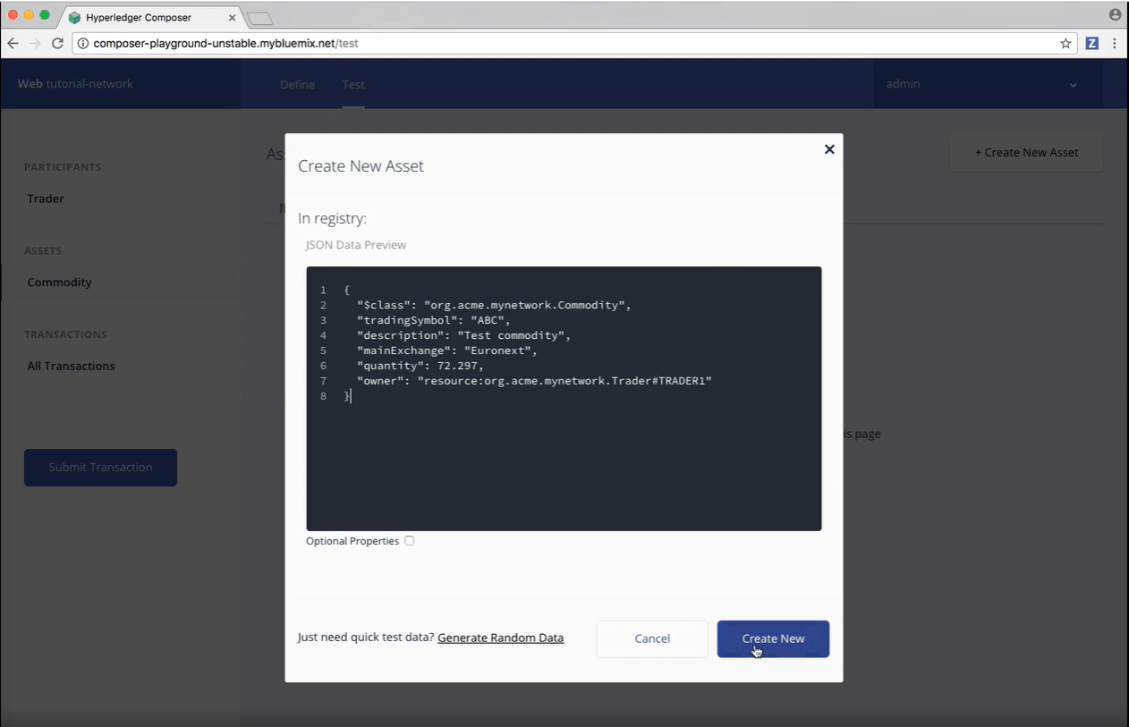

**Step Eleven: Transferring the commodity between the participants**

Now that we have two Traders and a Commodity to trade between them, we can test our Trade transaction.

Transactions are the basis of all change in a Hyperledger Composer business network, if you want to experiment with your own after this tutorial, try creating another business network from the My Business Network screen and using a more advanced business network template.

To test the Trade transaction:

1. Click the Submit Transaction button on the left.
2. Ensure that the transaction type is Trade.
3. Replace the transaction data with the following, or just change the details:

{

"$class": "org.acme.mynetwork.Trade",

"commodity": "resource:org.acme.mynetwork.Commodity#ABC",

"newOwner": "resource:org.acme.mynetwork.Trader#TRADER2"

}

1. Click Submit.
2. Check that our asset has changed ownership from TRADER1 to TRADER2, by expanding the data section for the asset. You should see that the owner is listed as resource:org.acme.mynetwork.Trader#TRADER2.
3. To view the full transaction history of our business network, click All Transactions on the left. Here is a list of each transaction as they were submitted. You can see that certain actions we performed using the UI, like creating the Trader participants and the Commodity asset, are recorded as transactions, even though they're not defined as transactions in our business network model. These transactions are known as 'System Transactions' and are common to all business networks, and defined in the Hyperledger Composer Runtime.

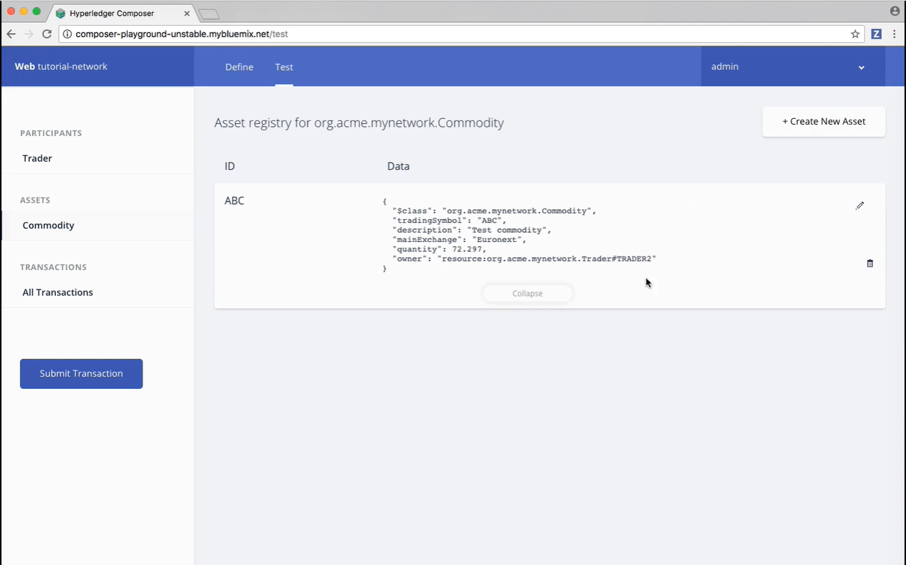

**Logging out of the business network**

Now that transactions have successfully run, we should log out of the business network, ending up at the My Business Network screen where we started.

In the upper-right of the screen is a button labelled admin. This lists your current identity, to log out, click admin to open the dropdown menu, and click My Business Networks.

**CONCLUSION:**

In this practical, we completed the initial Hyperledger Composer Playground tutorial. We walked through setting up a business network, defining our assets, participants and transactions, and testing our network by creating some participants and an asset, and submitting transactions to change the ownership of the asset from one to another.

**PRACTICAL 8**

**AIM:**

Create Decentralized application “Voting” using Ethereum. Set up development environment using Truffle framework and Ganache, Metamask of chrome extension.

**PREREQUISITES:**

* Nodejs
* Ganache
* Truffle
* Metamask Extension

**Steps to make Decentralized Election system:**

1. First make an empty directory and then run below command in cmd to download and unbox pet-shop example.
   1. truffle unbox pet-shop

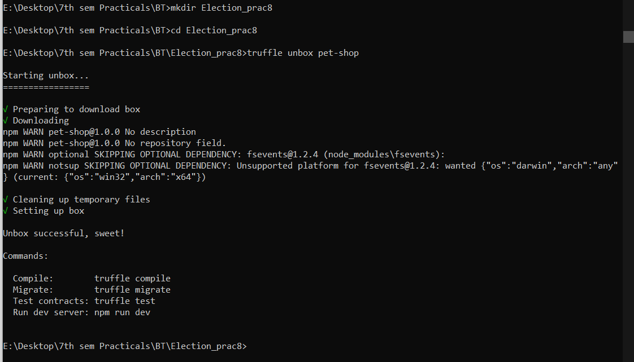

1. now you can see the file structure like below image in that empty directory.

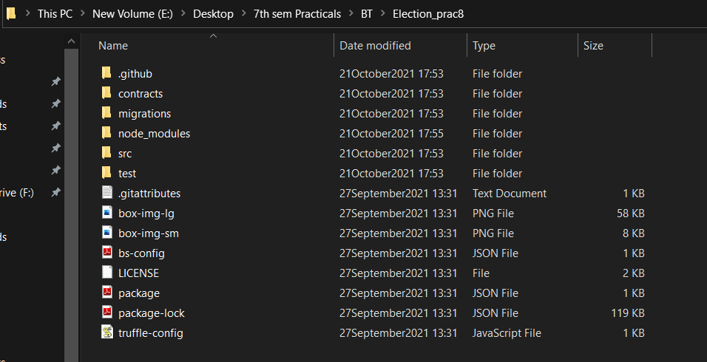

1. now go to contracts folder and you can see one migrations.sol file so you have to make same file as migrations.sol and name as **“Election.sol”** and then write below code into that file and save it.

**Election.sol**

pragma solidity 0.5.16;

contract Election {

// Model a Candidate

struct Candidate {

uint id;

string name;

uint voteCount;

}

// Store accounts that have voted

mapping(address => bool) public voters;

// Store Candidates

// Fetch Candidate

mapping(uint => Candidate) public candidates;

// Store Candidates Count

uint public candidatesCount;

// voted event

event votedEvent (

uint indexed _candidateId

);

constructor () public {

addCandidate("Candidate 1");

addCandidate("Candidate 2");

}

function addCandidate (string memory _name) private {

candidatesCount ++;

candidates[candidatesCount] = Candidate(candidatesCount, _name, 0);

}

function vote (uint _candidateId) public {

// require that they haven't voted before

require(!voters[msg.sender]);

// require a valid candidate

require(_candidateId > 0 && _candidateId <= candidatesCount);

// record that voter has voted

voters[msg.sender] = true;

// update candidate vote Count

candidates[_candidateId].voteCount ++;

// trigger voted event

emit votedEvent(_candidateId);

}

}

1. now go to migrations folder there you can see the file named as “1_initial_migration.js” same as above step you have to create a file named as **“2_deploy_contracts.js”** and add below code into that file and save it.

**Note : the sol file name will be considered in this file so as we have created Election.sol so that the file will be called in this file.**

**2_deploy_contracts.js**

var Election = artifacts.require("./Election.sol");

module.exports = function(deployer) {

deployer.deploy(Election);

};

1. so we are ready to create our frontend part of this application.
2. Go to src folder and see the index.html and you can create your own frontend but for reference the code of the frontend is below.

**Index.html**

<!DOCTYPE html>

<html lang="en">

<head>

<meta charset="utf-8">

<meta http-equiv="X-UA-Compatible" content="IE=edge">

<meta name="viewport" content="width=device-width, initial-scale=1">

<!-- The above 3 meta tags *must* come first in the head; any other head content must come *after* these tags -->

<title>Election Results</title>

<!-- Bootstrap -->

<link href="css/bootstrap.min.css" rel="stylesheet">

<!-- HTML5 shim and Respond.js for IE8 support of HTML5 elements and media queries -->

<!-- WARNING: Respond.js doesn't work if you view the page via file:// -->

<!--[if lt IE 9]>

<script src="https://oss.maxcdn.com/html5shiv/3.7.3/html5shiv.min.js"></script>

<script src="https://oss.maxcdn.com/respond/1.4.2/respond.min.js"></script>

<![endif]-->

</head>

<body>

<div class="container" style="width: 650px;">

<div class="row">

<div class="col-lg-12">

<h1 class="text-center">Election Results</h1>

<hr/>

<br/>

<div id="loader">

<p class="text-center">Loading...</p>

</div>

<div id="content" style="display: none;">

<table class="table">

<thead>

<tr>

<th scope="col">#</th>

<th scope="col">Name</th>

<th scope="col">Votes</th>

</tr>

</thead>

<tbody id="candidatesResults">

</tbody>

</table>

<hr/>

<form onSubmit="App.castVote(); return false;">

<div class="form-group">

<label for="candidatesSelect">Select Candidate</label>

<select class="form-control" id="candidatesSelect">

</select>

</div>

<button type="submit" class="btn btn-primary">Vote</button>

<hr />

</form>

<p id="accountAddress" class="text-center"></p>

</div>

</div>

</div>

</div>

<!-- jQuery (necessary for Bootstrap's JavaScript plugins) -->

<script src="https://ajax.googleapis.com/ajax/libs/jquery/1.12.4/jquery.min.js"></script>

<!-- Include all compiled plugins (below), or include individual files as needed -->

<script src="js/bootstrap.min.js"></script>

<script src="js/web3.min.js"></script>

<script src="js/truffle-contract.js"></script>

<script src="js/app.js"></script>

</body>

</html>

1. Now to connect metamask with our own created application we have to do some changes into the app.js file so go to src folder and then go to js folder and open js file then copy below code and paste it there.

**app.js**

App = {

web3Provider: null,

contracts: {},

account: '0x0',

hasVoted: false,

init: function() {

return App.initWeb3();

},

initWeb3: function() {

// TODO: refactor conditional

if (typeof web3 !== 'undefined') {

// If a web3 instance is already provided by Meta Mask.

App.web3Provider = web3.currentProvider;

web3 = new Web3(web3.currentProvider);

} else {

// Specify default instance if no web3 instance provided

App.web3Provider = new Web3.providers.HttpProvider('http://127.0.0.1:7545');

web3 = new Web3(App.web3Provider);

}

return App.initContract();

},

initContract: function() {

$.getJSON("Election.json", function(election) {

// Instantiate a new truffle contract from the artifact

App.contracts.Election = TruffleContract(election);

// Connect provider to interact with contract

App.contracts.Election.setProvider(App.web3Provider);

App.listenForEvents();

return App.render();

});

},

// Listen for events emitted from the contract

listenForEvents: function() {

App.contracts.Election.deployed().then(function(instance) {

// Restart Chrome if you are unable to receive this event

// This is a known issue with Metamask

// https://github.com/MetaMask/metamask-extension/issues/2393

instance.votedEvent({}, {

fromBlock: 0,

toBlock: 'latest'

}).watch(function(error, event) {

console.log("event triggered", event)

// Reload when a new vote is recorded

App.render();

});

});

},

render: function() {

var electionInstance;

var loader = $("#loader");

var content = $("#content");

loader.show();

content.hide();

// Load account data

web3.eth.getCoinbase(function(err, account) {

if (err === null) {

App.account = account;

$("#accountAddress").html("Your Account: " + account);

}

});

// Load contract data

App.contracts.Election.deployed().then(function(instance) {

electionInstance = instance;

return electionInstance.candidatesCount();

}).then(function(candidatesCount) {

var candidatesResults = $("#candidatesResults");

candidatesResults.empty();

var candidatesSelect = $('#candidatesSelect');

candidatesSelect.empty();

for (var i = 1; i <= candidatesCount; i++) {

electionInstance.candidates(i).then(function(candidate) {

var id = candidate[0];

var name = candidate[1];

var voteCount = candidate[2];

// Render candidate Result

var candidateTemplate = "<tr><th>" + id + "</th><td>" + name + "</td><td>" + voteCount + "</td></tr>"

candidatesResults.append(candidateTemplate);

// Render candidate ballot option

var candidateOption = "<option value='" + id + "' >" + name + "</ option>"

candidatesSelect.append(candidateOption);

});

}

return electionInstance.voters(App.account);

}).then(function(hasVoted) {

// Do not allow a user to vote

if(hasVoted) {

$('form').hide();

}

loader.hide();

content.show();

}).catch(function(error) {

console.warn(error);

});

},

castVote: function() {

var candidateId = $('#candidatesSelect').val();

App.contracts.Election.deployed().then(function(instance) {

return instance.vote(candidateId, { from: App.account });

}).then(function(result) {

// Wait for votes to update

$("#content").hide();

$("#loader").show();

}).catch(function(err) {

console.error(err);

});

}

};

$(function() {

$(window).load(function() {

App.init();

});

});

1. So we are almost ready to launch the frontend, but lets first make one last file into the test folder named as **“election.js”** and write below code into that file.

**election.js**

var Election = artifacts.require("./Election.sol");

contract("Election", function(accounts) {

var electionInstance;

it("initializes with two candidates", function() {

return Election.deployed().then(function(instance) {

return instance.candidatesCount();

}).then(function(count) {

assert.equal(count, 2);

});

});

it("it initializes the candidates with the correct values", function() {

return Election.deployed().then(function(instance) {

electionInstance = instance;

return electionInstance.candidates(1);

}).then(function(candidate) {

assert.equal(candidate[0], 1, "contains the correct id");

assert.equal(candidate[1], "Candidate 1", "contains the correct name");

assert.equal(candidate[2], 0, "contains the correct votes count");

return electionInstance.candidates(2);

}).then(function(candidate) {

assert.equal(candidate[0], 2, "contains the correct id");

assert.equal(candidate[1], "Candidate 2", "contains the correct name");

assert.equal(candidate[2], 0, "contains the correct votes count");

});

});

it("allows a voter to cast a vote", function() {

return Election.deployed().then(function(instance) {

electionInstance = instance;

candidateId = 1;

return electionInstance.vote(candidateId, { from: accounts[0] });

}).then(function(receipt) {

assert.equal(receipt.logs.length, 1, "an event was triggered");

assert.equal(receipt.logs[0].event, "votedEvent", "the event type is correct");

assert.equal(receipt.logs[0].args._candidateId.toNumber(), candidateId, "the candidate id is correct");

return electionInstance.voters(accounts[0]);

}).then(function(voted) {

assert(voted, "the voter was marked as voted");

return electionInstance.candidates(candidateId);

}).then(function(candidate) {

var voteCount = candidate[2];

assert.equal(voteCount, 1, "increments the candidate's vote count");

})

});

it("throws an exception for invalid candiates", function() {

return Election.deployed().then(function(instance) {

electionInstance = instance;

return electionInstance.vote(99, { from: accounts[1] })

}).then(assert.fail).catch(function(error) {

assert(error.message.indexOf('revert') >= 0, "error message must contain revert");

return electionInstance.candidates(1);

}).then(function(candidate1) {

var voteCount = candidate1[2];

assert.equal(voteCount, 1, "candidate 1 did not receive any votes");

return electionInstance.candidates(2);

}).then(function(candidate2) {

var voteCount = candidate2[2];

assert.equal(voteCount, 0, "candidate 2 did not receive any votes");

});

});

it("throws an exception for double voting", function() {

return Election.deployed().then(function(instance) {

electionInstance = instance;

candidateId = 2;

electionInstance.vote(candidateId, { from: accounts[1] });

return electionInstance.candidates(candidateId);

}).then(function(candidate) {

var voteCount = candidate[2];

assert.equal(voteCount, 1, "accepts first vote");

// Try to vote again

return electionInstance.vote(candidateId, { from: accounts[1] });

}).then(assert.fail).catch(function(error) {

assert(error.message.indexOf('revert') >= 0, "error message must contain revert");

return electionInstance.candidates(1);

}).then(function(candidate1) {

var voteCount = candidate1[2];

assert.equal(voteCount, 1, "candidate 1 did not receive any votes");

return electionInstance.candidates(2);

}).then(function(candidate2) {

var voteCount = candidate2[2];

assert.equal(voteCount, 1, "candidate 2 did not receive any votes");

});

});

});

1. Our part is almost done so open ganache you will get 2 options like below image.

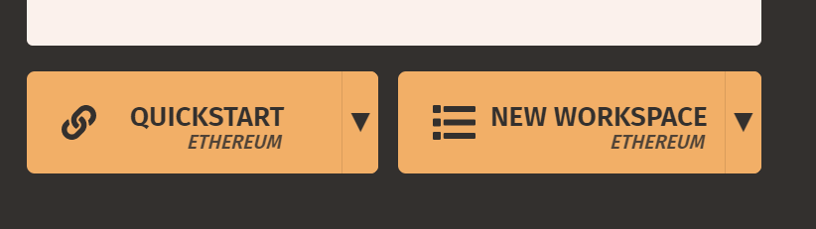

1. Choose new workspace and name that you want. Then click on add project and choose **“truffle-config.js”** and then click on save workspace.

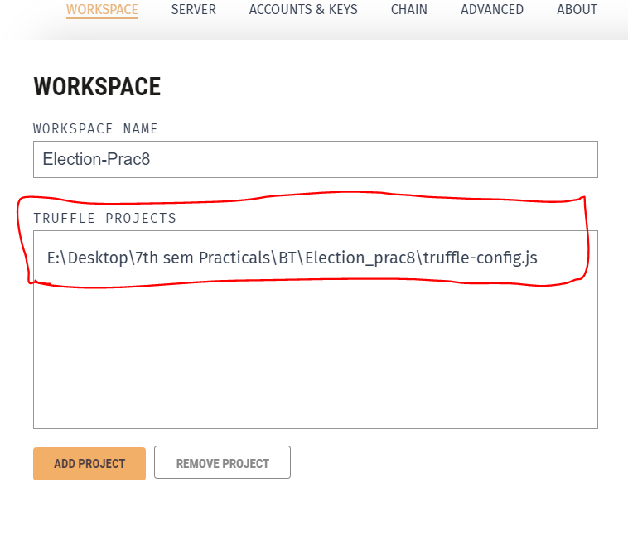

1. Now open cmd and run below command in the project folder.
   1. truffle migrate

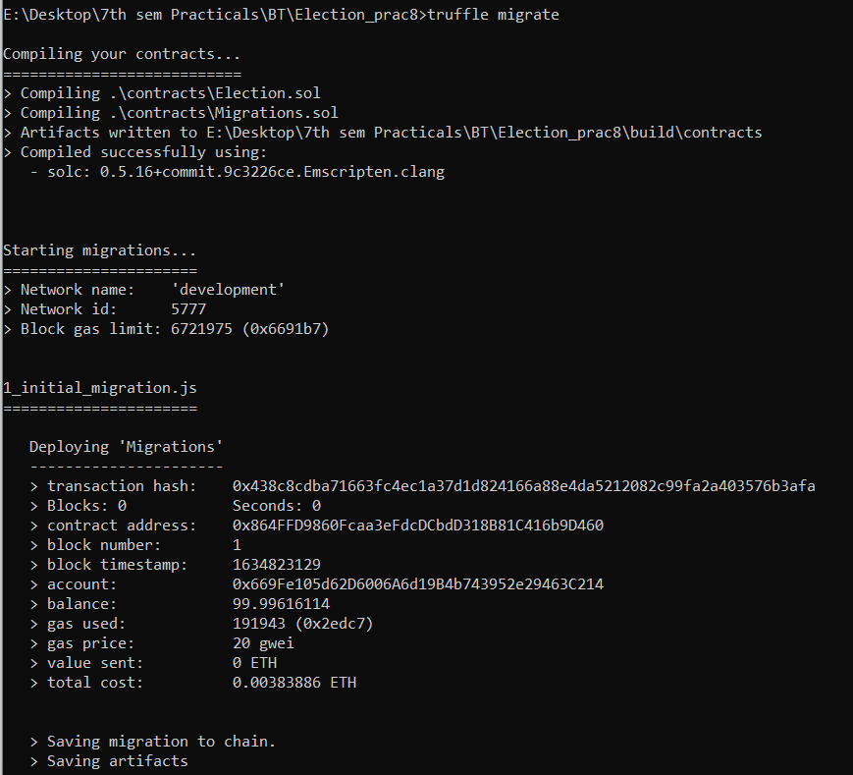

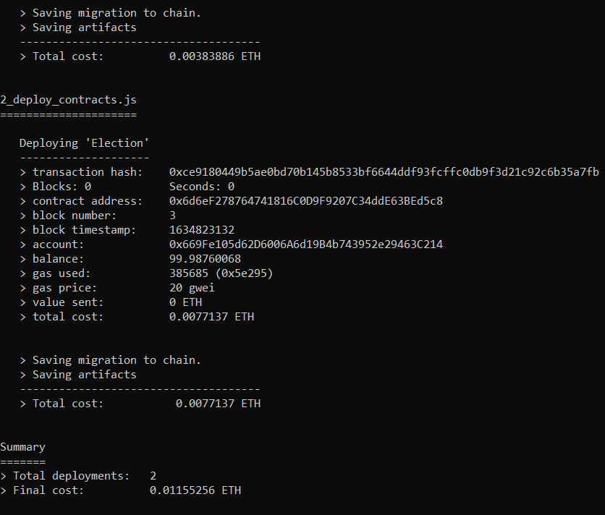

1. you can see the transaction into the transactions panel of ganache and you can also see the contract that you have deployed just some seconds ago.

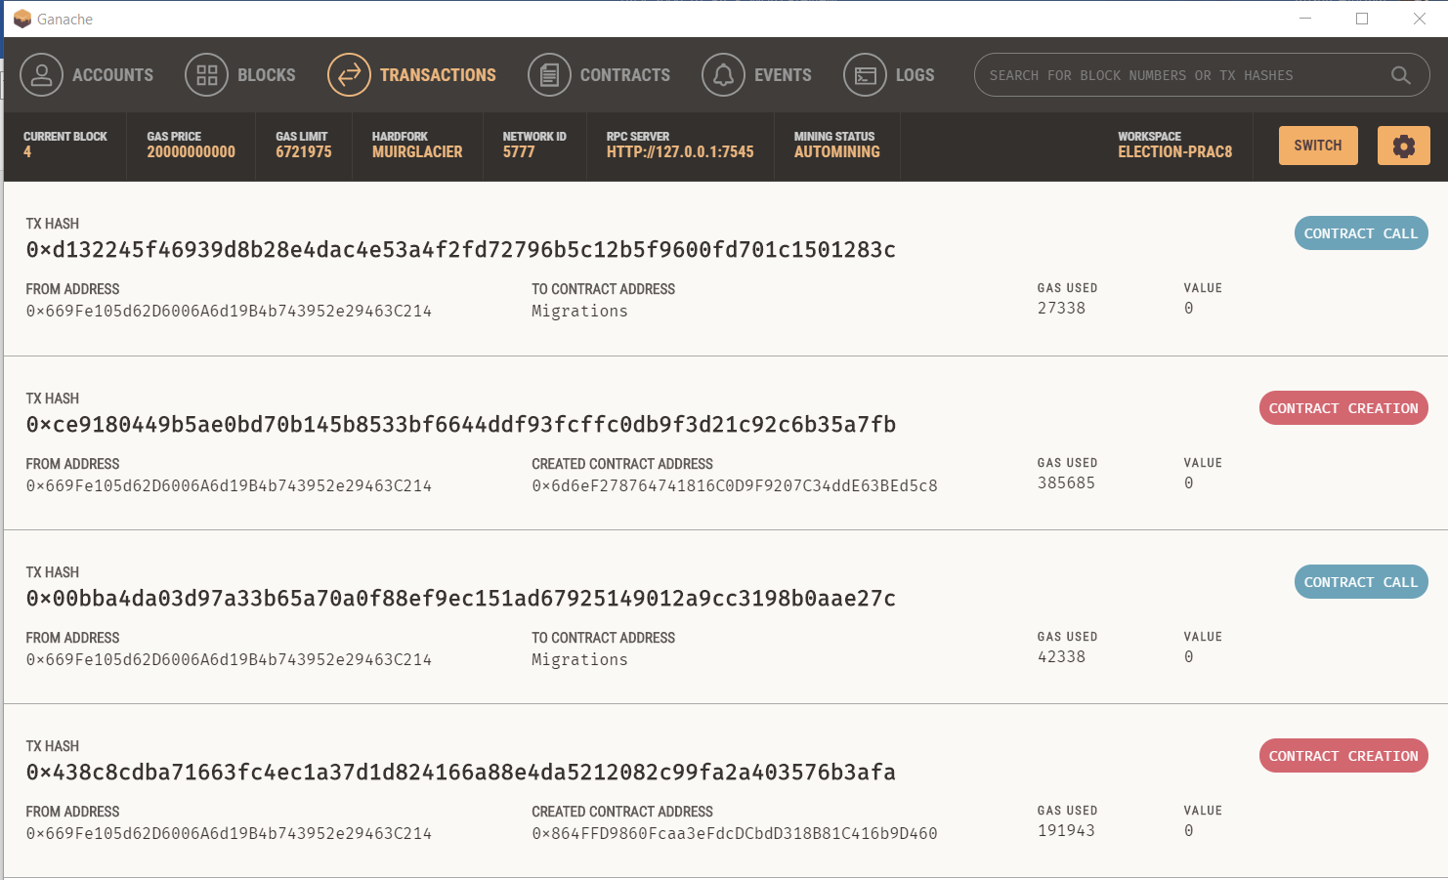

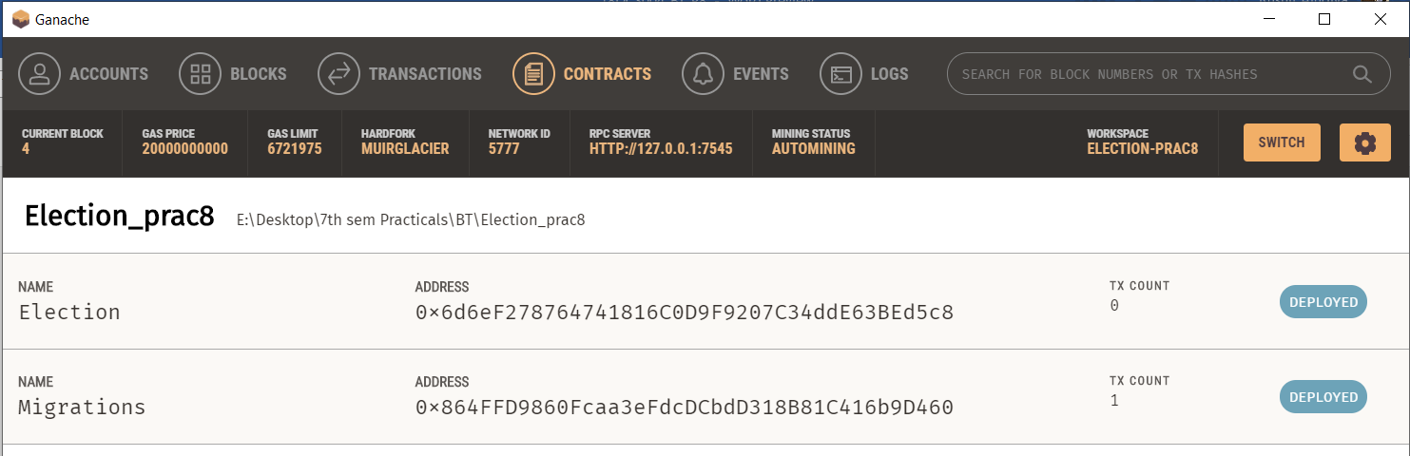

1. run below command to see the frontend part into your localhost browser.
   1. npm run dev

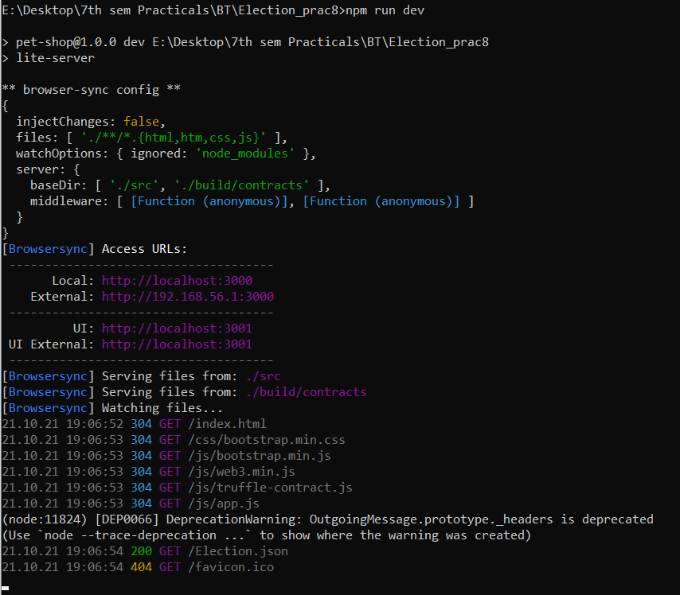

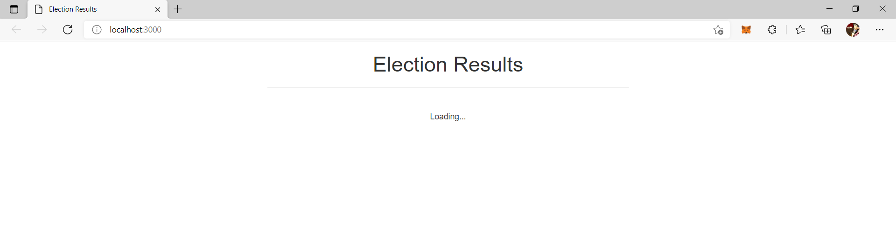

1. now we have to connect the metamask with our application. Open metamask from extension panel in your browser then go to custom rpc in the network section.

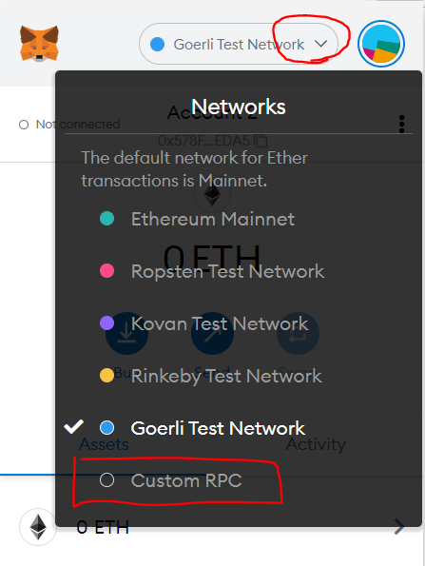

1. now fill the details from below image and click on save button.

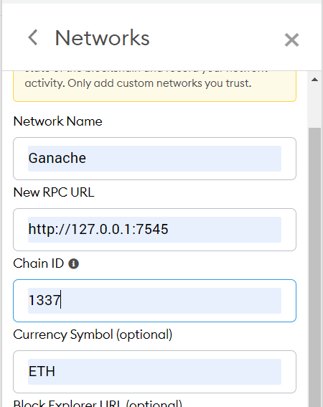

1. go to account section and the click on import account.

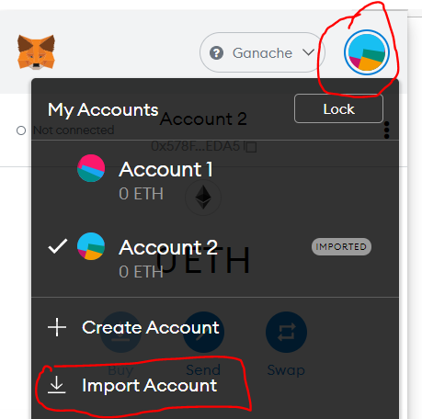

1. you can get the private key from the ganache account panel you can see the steps in below images. Then copy the private key and paste it into the metamask and click on import.

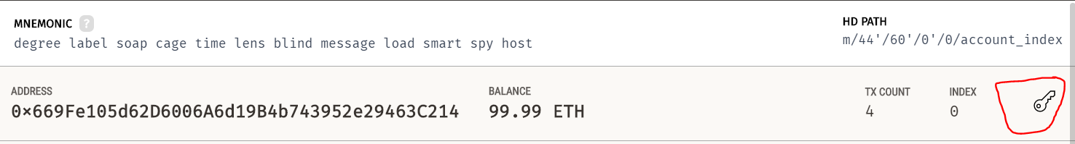

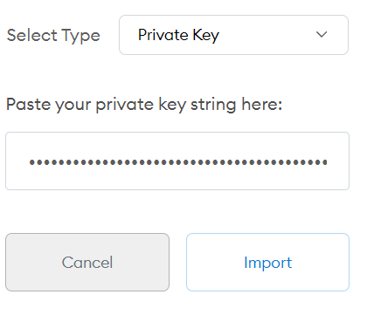

1. click on **“not connected”** to connect to the localhost.

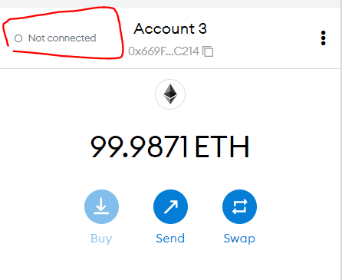

1. if you get an error like below image then follow step 20.

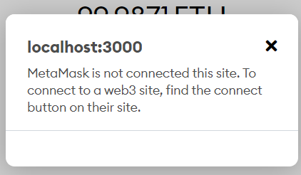

1. click on the three dots and the click on connected sites. Then click on manually connect to the current site. Select account and click on next and then click on connect.

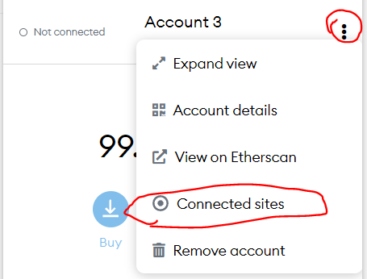

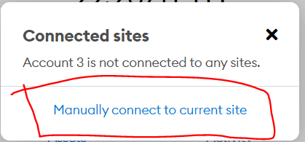

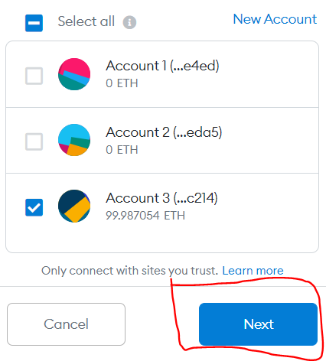

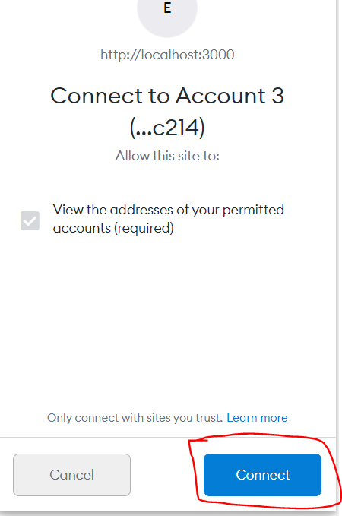

1. after connecting to the metamask you can see the frontend like below image.

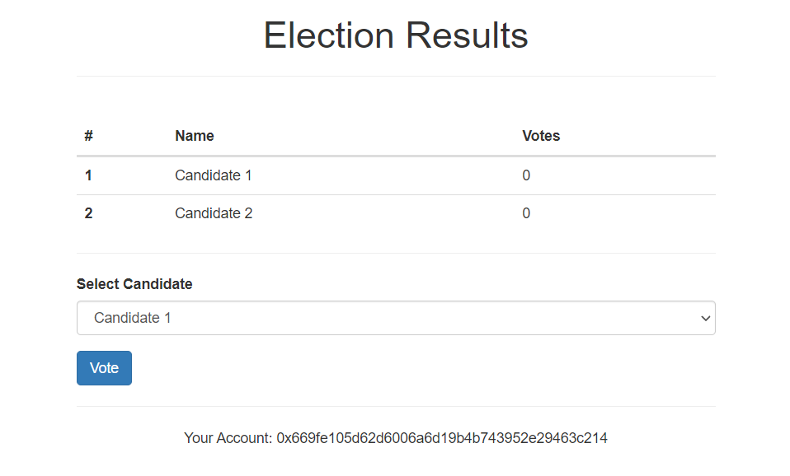

1. you can vote any candidate by choosing from drop down menu and by clicking on vote button. You can also change account and then you can vote from second account.

**OUTPUT:**

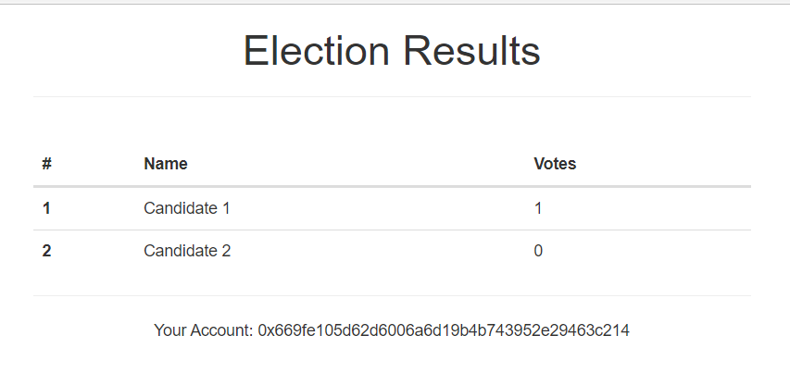

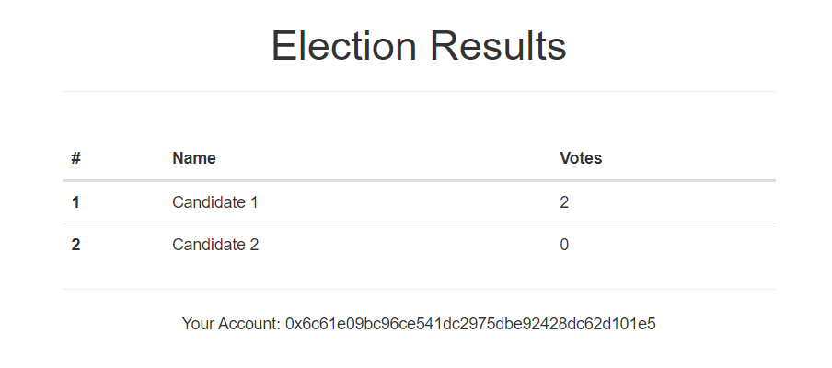

**CONCLUSION:**

In this practical, we thoroughly understood the concept of ganache, Truffle and implemented basic election system using it.

**PRACTICAL 9**

**AIM:**

Build the private blockchain network using Geth.

**STEPS OF IMPLEMENTATION:**

First we will create a main directory. Here we’re naming it “new_geth” but any name will work. Then in cmd, we will navigate to it.

cd new_geth

Then we will make 2 directories inside that folder. We’re naming then n1 and peernode.

mkdir n1

mkdir Peernode



Then we will create new accounts in both the folders with following commands.

geth --datadir ./n1 account new

geth --datadir ./Peernode account new



That would generate public address of both accounts.

We will create genesis.json file in both directories with following code.

{

"config": {

"chainId": 1234,

"homesteadBlock": 0,

"eip150Block": 0,

"eip150Hash": "0x0000000000000000000000000000000000000000000000000000000000000000",

"eip155Block": 0,

"eip158Block": 0,

"byzantiumBlock": 0

},

"difficulty": "400",

"gasLimit": "2000000",

"alloc": {

"<public-address-of-the-key>": {

"balance": "500000000000000000000000"

}

}

}

Then we will initiate both the genesis blocks.

geth --datadir ./n1 init n1/genesis.json

geth --datadir ./Peernode init Peernode/genesis.json



Then we will start interactive javascript environment to interact with our newly created blockchain.

geth --datadir ./n1 --networkid 1234 --ipcdisable --rpc --rpccorsdomain "*" --rpcapi "db,eth,net,web3,personal" --rpcaddr "0.0.0.0" console



To check balance in our account, we will simply type the following command while the background process is still running.

eth.getBalance(web3.eth.accounts[0])



Admin object exposes methods to interact with the RPC APIs. To get information about enode, we will write following command.

admin.nodeInfo.enode



We will copy this enode address and Request adding a new remote node to the list of tracked static nodes.

admin.addPeer("paste the enode address")



To check your the etherbase account balance, we will use…

eth.getBalance(eth.coinbase)



Now we will set the etherbase, where mining rewards will go.

miner.setEtherbase(web3.eth.accounts[0])



Then finally, we are ready to mine some Ethereum now.

miner.start()



To stop that process, we can use…

miner.stop()



Now we will again check balance with following command. Ideally balance will be less than previous balance i.e. the transaction fees deducted.

eth.getBalance(eth.coinbase)



**CONCLUSION:**

In this practical, we used command prompt and geth to create our private Ethereum blockchain and we mined some Ethereum using it.

**PRACTICAL 10**

**AIM:**

Setup private parity Ethereum POA blockchain network.

**PRACTICAL:**

We will first create a virtual machine on AWS.

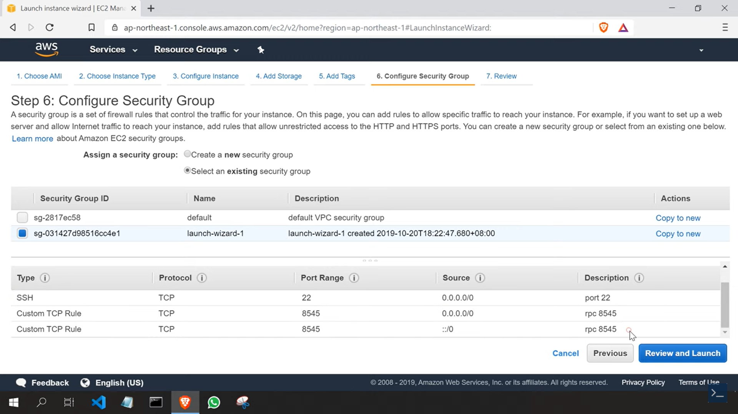

We need to install parity for creation of blockchain which can be installed from aws itself.

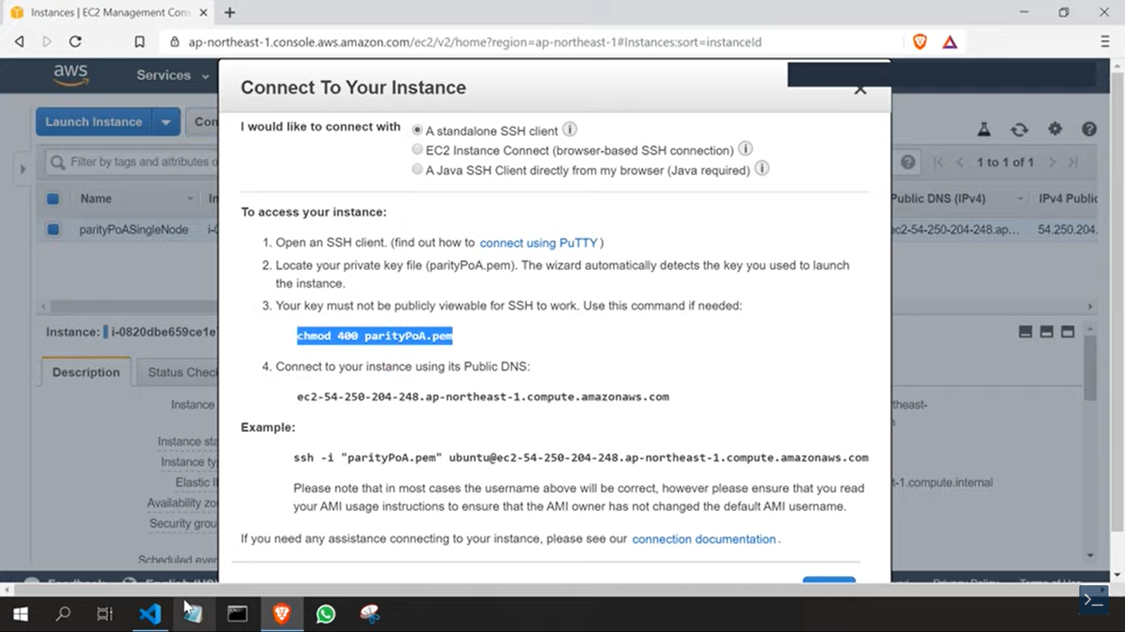

After performing the written instructions, we can check on terminal if it’s successfully installed.

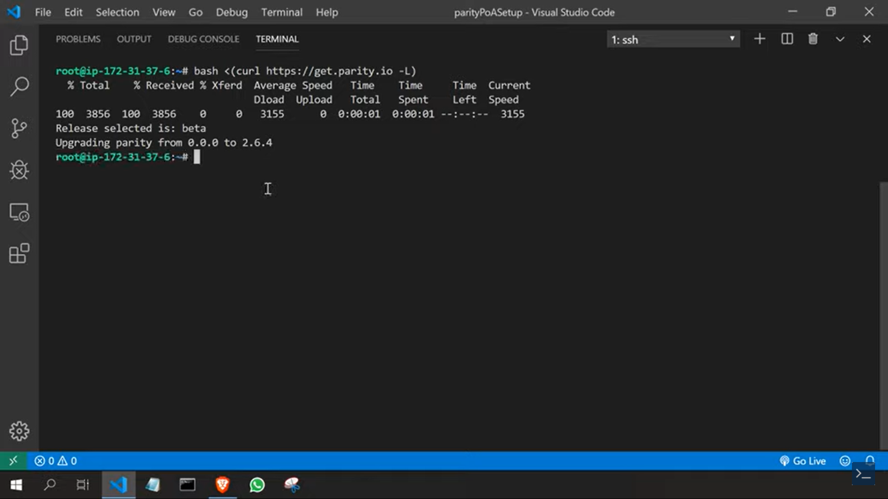

We will now setup the folder structure for our blockchain like shown in the figure.

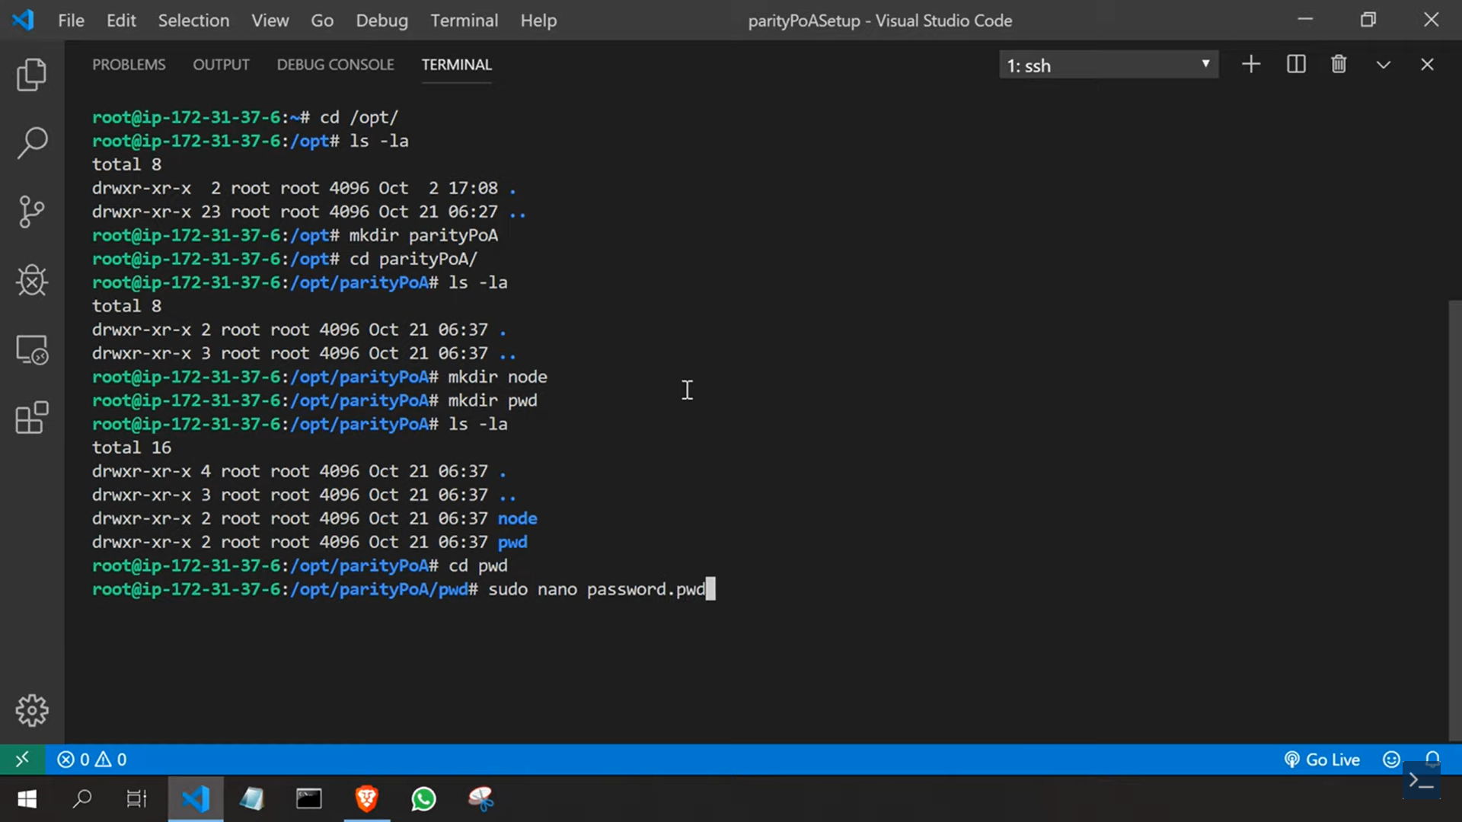

In password.pwd file, we will set our password.

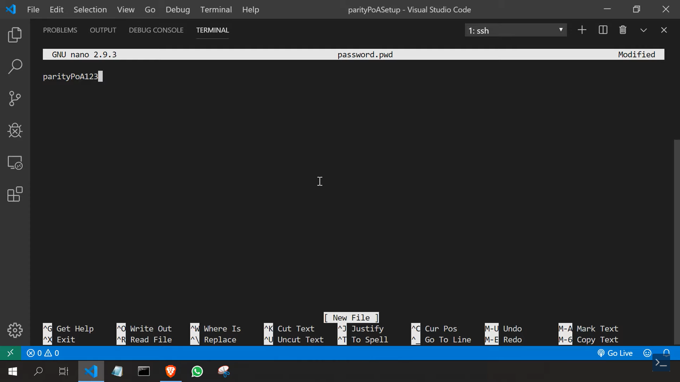

We will now create a file called parityGenesis.json which will keep data about genesis block of our blockchain.

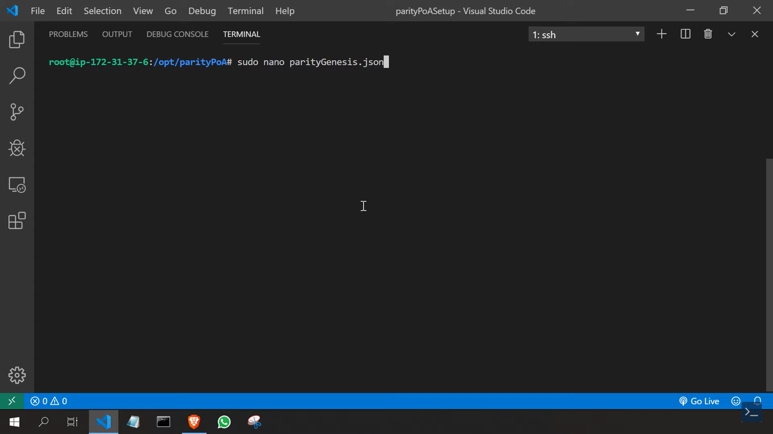

Then we will open myetherwallet.com and go to keystore to download the file.

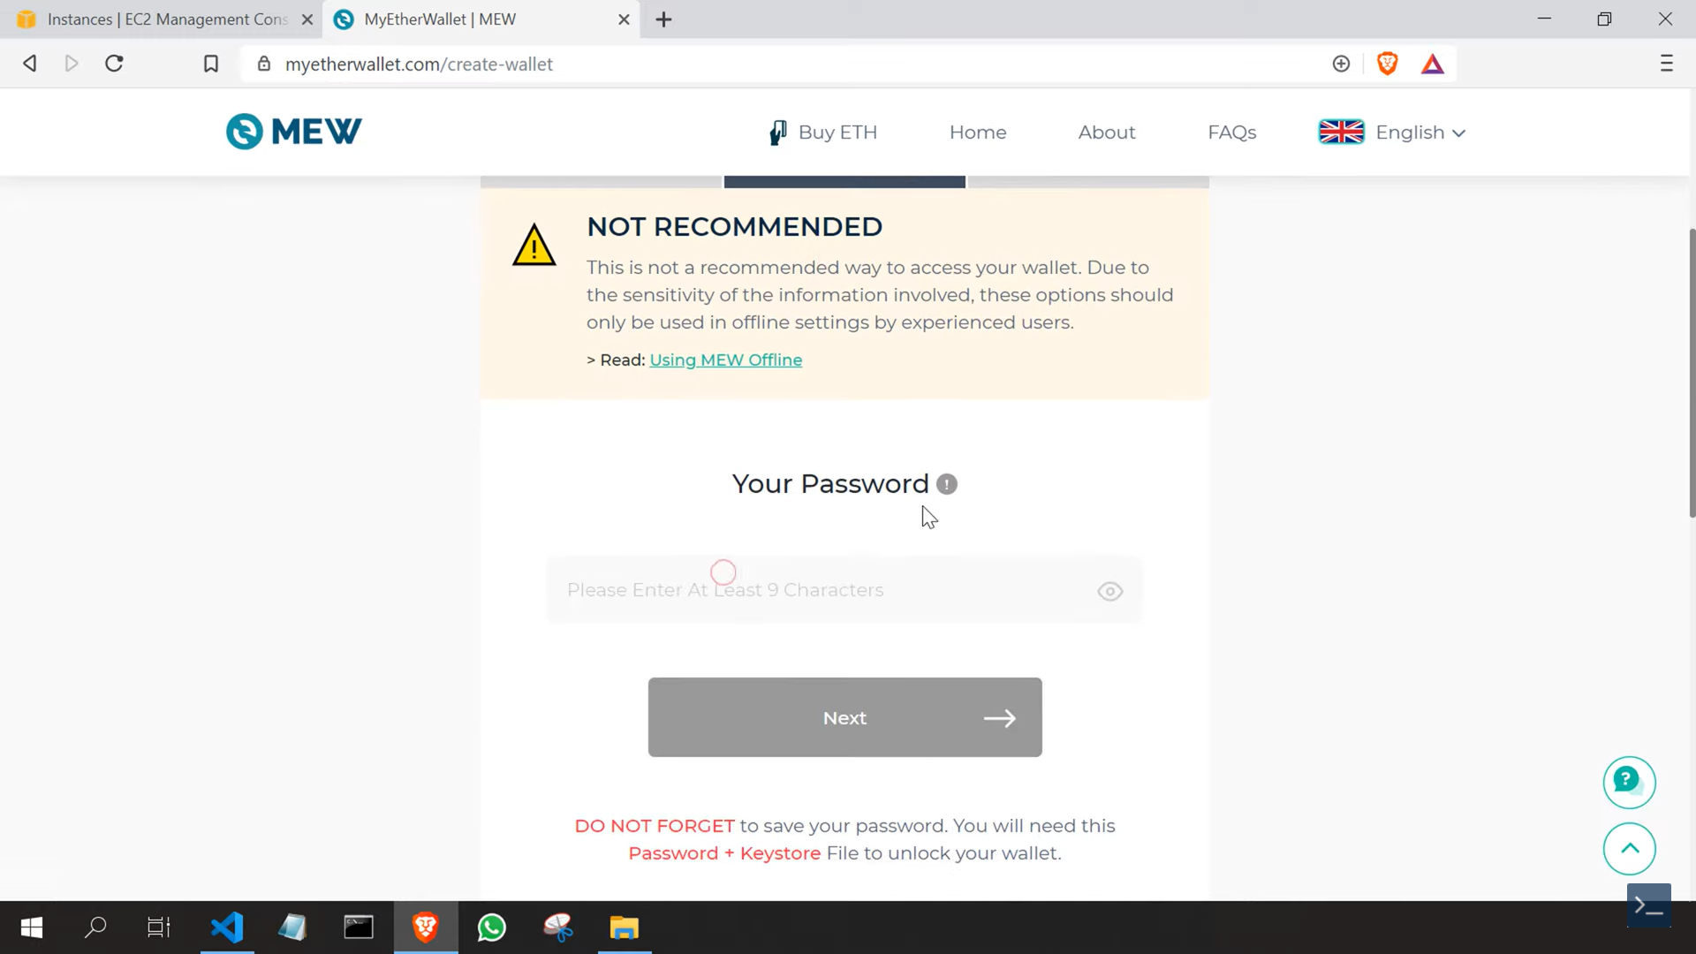

We will copy that content of downloaded file to our node file.

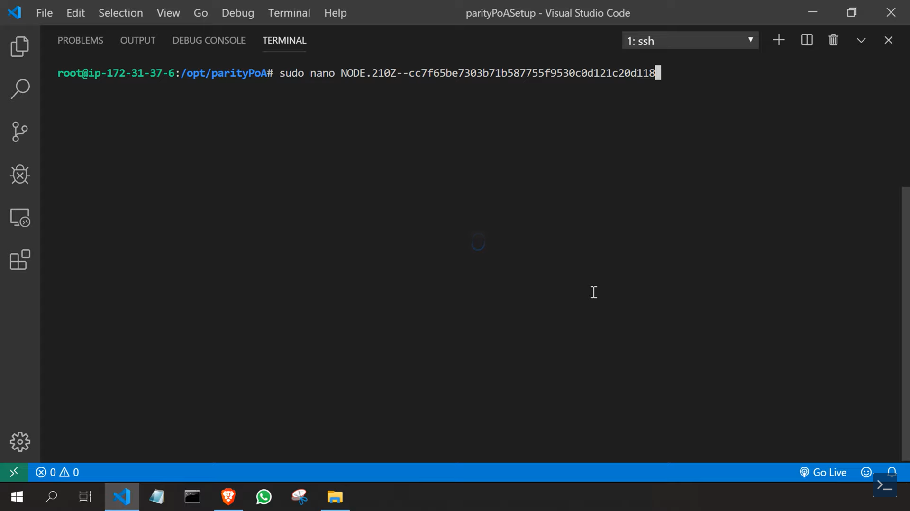

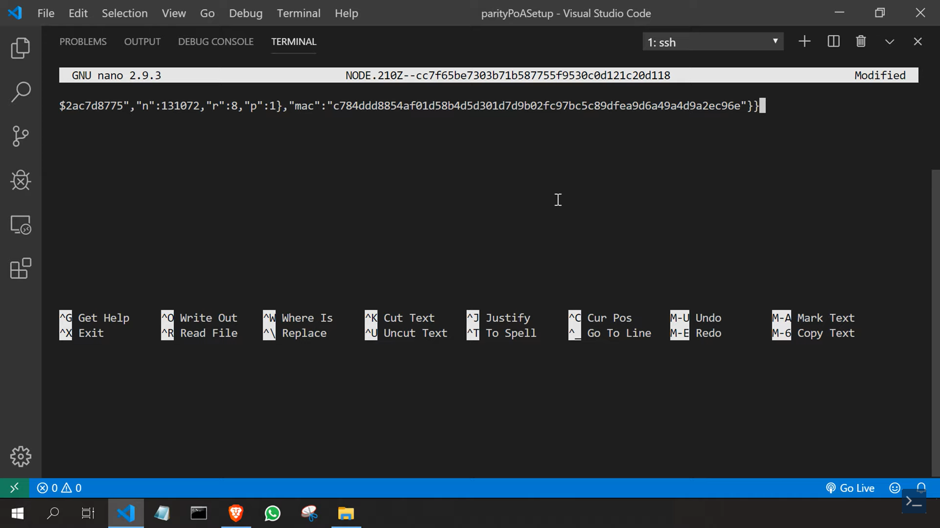

Now we will add the following lines to our parityGenesis.json

{

"name": "parityGenesis",

"engine": {

"authorityRound": {

"params": {

"stepDuration": "5",

"validators" : {

"multi": {

"0": {

"list": [""]

}

}

}

}

}

},

"params": {

"gasLimitBoundDivisor": "0x400",

"maximumExtraDataSize": "0x20",

"minGasLimit": "0x7A1200",

"networkID" : "0x2323",

"eip155Transition": 0,

"validateChainIdTransition": 0,

"eip140Transition": 0,

"eip211Transition": 0,

"eip214Transition": 0,

"eip658Transition": 0,

"eip150Transition": "0x0",

"eip160Transition": "0x0",

"eip161abcTransition": "0x0",

"eip161dTransition": "0x0",

"eip98Transition": "0x7fffffffffffff",

"maxCodeSize": 24576,

"maxCodeSizeTransition": "0x0"

},

"genesis": {

"seal": {

"authorityRound": {

"step": "0x0",

"signature": "0x0000000000000000000000000000000000000000000000000000000000000000000000000000000000000000000000000000000000000000000000000000000000"

}

},

"difficulty": "0x20000",

"gasLimit": "0x7A1200"

},

"accounts": {

"0x0000000000000000000000000000000000000001": { "balance": "1", "builtin": { "name": "ecrecover", "pricing": { "linear": { "base": 3000, "word": 0 } } } },

"0x0000000000000000000000000000000000000002": { "balance": "1", "builtin": { "name": "sha256", "pricing": { "linear": { "base": 60, "word": 12 } } } },

"0x0000000000000000000000000000000000000003": { "balance": "1", "builtin": { "name": "ripemd160", "pricing": { "linear": { "base": 600, "word": 120 } } } },

"0x0000000000000000000000000000000000000004": { "balance": "1", "builtin": { "name": "identity", "pricing": { "linear": { "base": 15, "word": 3 } } } },

"0x0000000000000000000000000000000000000005": { "builtin": { "name": "modexp", "activate_at": 0, "pricing": { "modexp": { "divisor": 20 } } } },

"0x0000000000000000000000000000000000000006": { "builtin": { "name": "alt_bn128_add", "activate_at": 0, "pricing": { "linear": { "base": 500, "word": 0 } } } },

"0x0000000000000000000000000000000000000007": { "builtin": { "name": "alt_bn128_mul", "activate_at": 0, "pricing": { "linear": { "base": 40000, "word": 0 } } } },

"0x0000000000000000000000000000000000000008": { "builtin": { "name": "alt_bn128_pairing", "activate_at": "0x0","eip1108_transition": "0x7fffffffffffff", "pricing": { "alt_bn128_pairing": { "base": 100000, "pair": 80000,"eip1108_transition_base": 45000, "eip1108_transition_pair": 34000 } } } }

}

}

We will add our address ID at highlighted position.

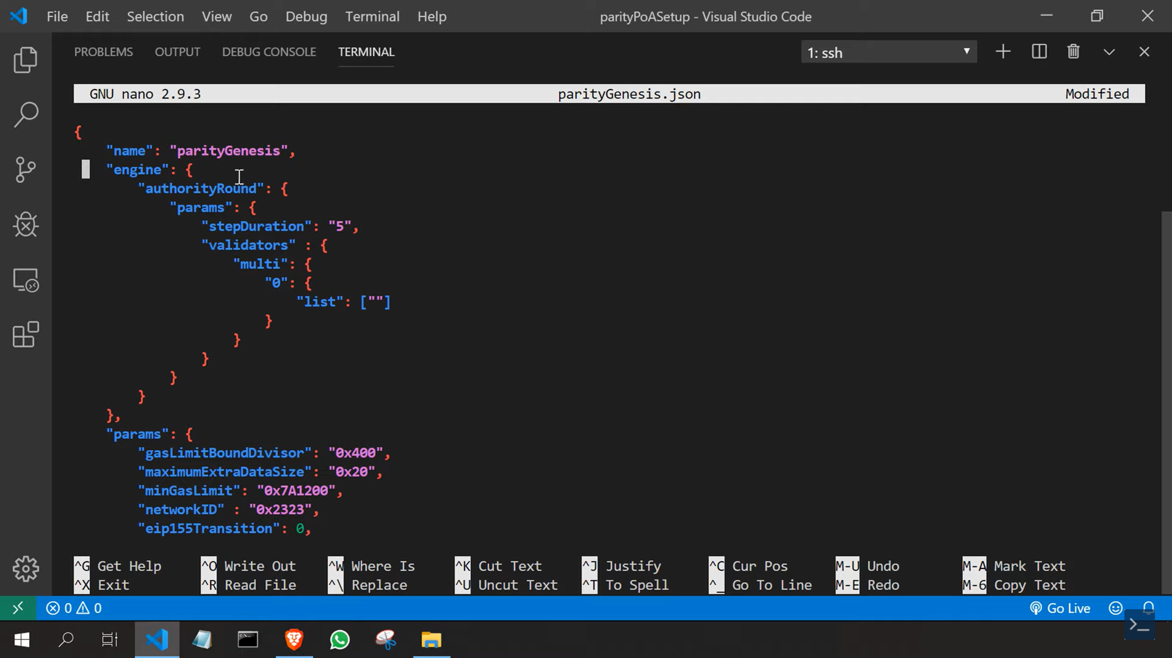

We will add node.toml data now.

# File singlenode.toml

[parity]

chain = "/opt/parityPoA/parityGenesis.json"

base_path = "/opt/parityPoA/node"

[network]

port = 30300

#bootnodes = []

[rpc]

interface = "all"

cors = ["all"]

hosts = ["all"]

port = 8545

apis = ["all"]

[websockets]

interface = "all"

port = 8546

origins = ["all"]

apis = ["web3", "eth", "net", "personal", "parity", "parity_set", "traces", "rpc", "parity_accounts"]

hosts = ["all"]

[account]

#password = ["/opt/parityPoA/pwd/password.pwd"]

[mining]

#engine_signer = ""

reseal_on_txs = "none"

force_sealing = true

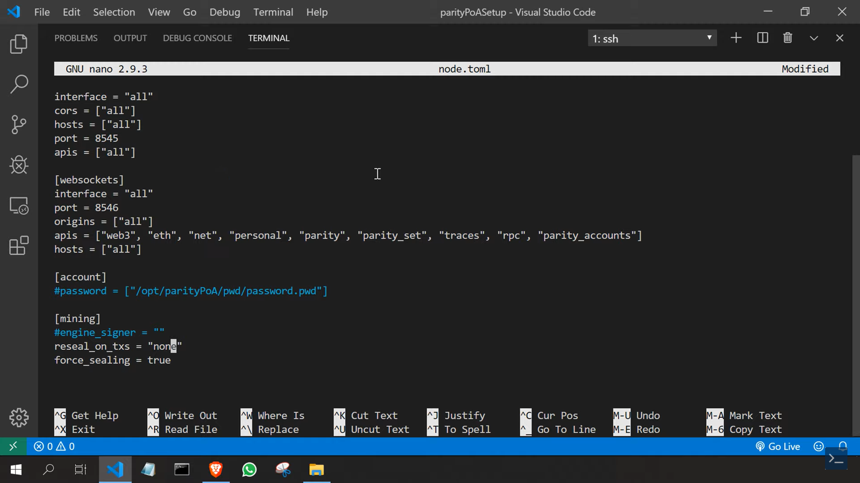

Now we will import the Ethereum account to node.

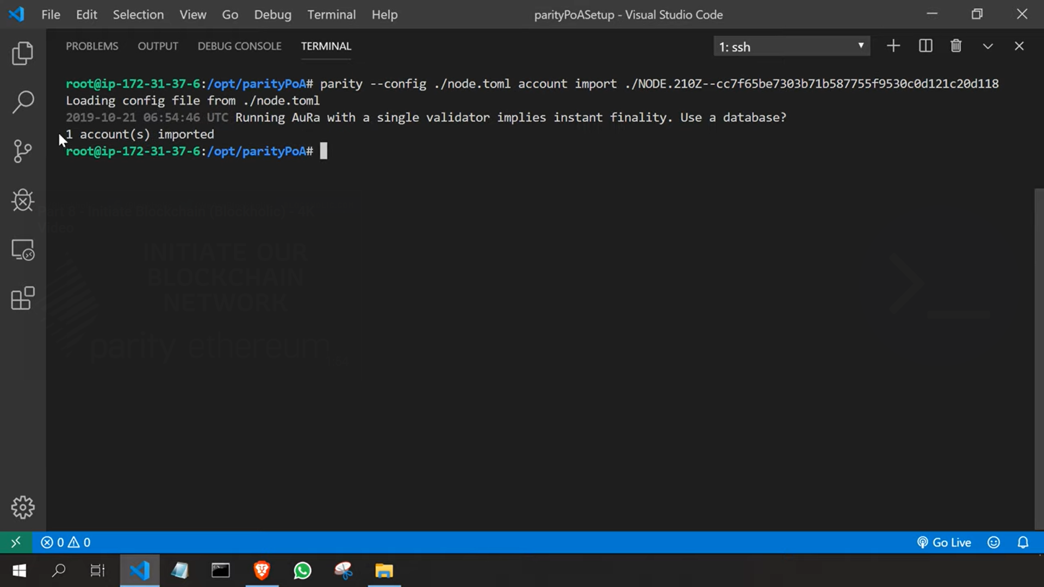

Finally, we will run our blockchain.

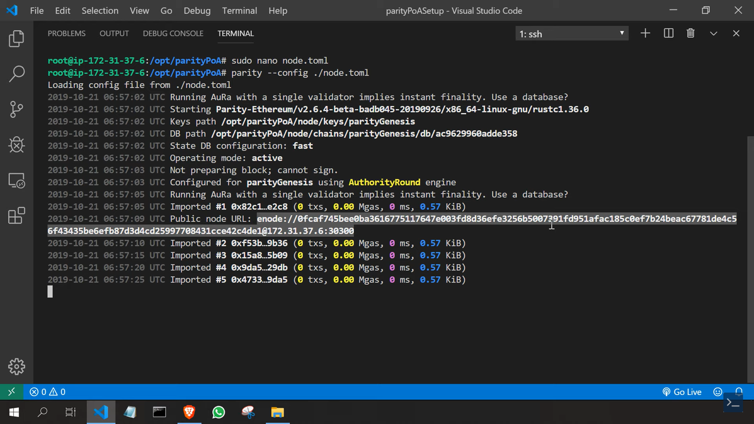

**CONCLUSION:**

In this practical, we learnt about parity and created our own blockchain using it.